User Manual
The Cache Buster modules is intended to be used for administrators and developers with administration access rights in Episerver.
The Cache Buster module could be helpful for both developers and administrators who understand how cache is used; for instance, to invalidate Content Output Cache in EPiServer.
This administration tool does the following:
- List all cache keys currently in use.

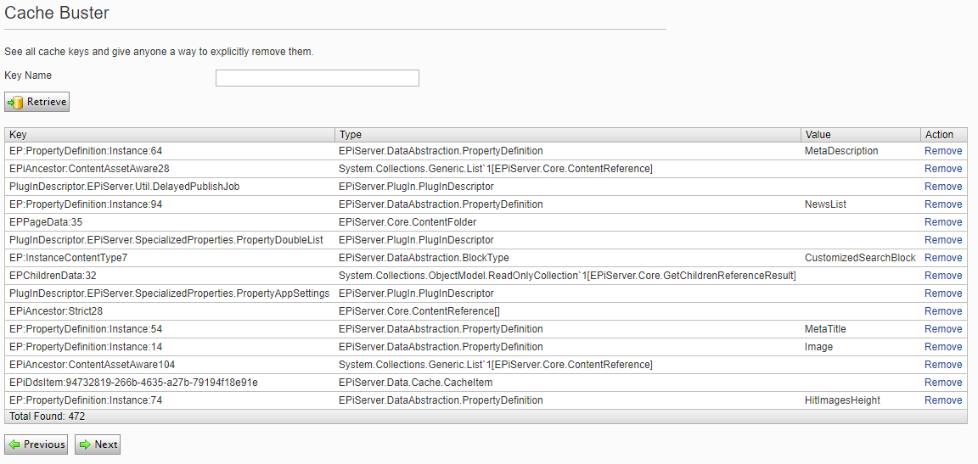

- Search for a specific key.

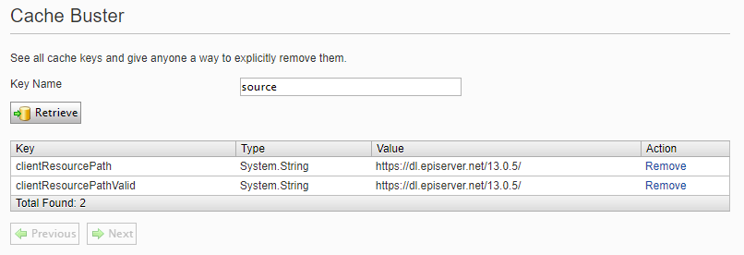

- Remove a key individually by clicking on the Remove link.

