User Manual
In order to use the Content Approval Plugin, you must go to the Admin section of the CMS and after it, to the Config Tab, Tool Settings and finally Content Approval Work Flow Plugin
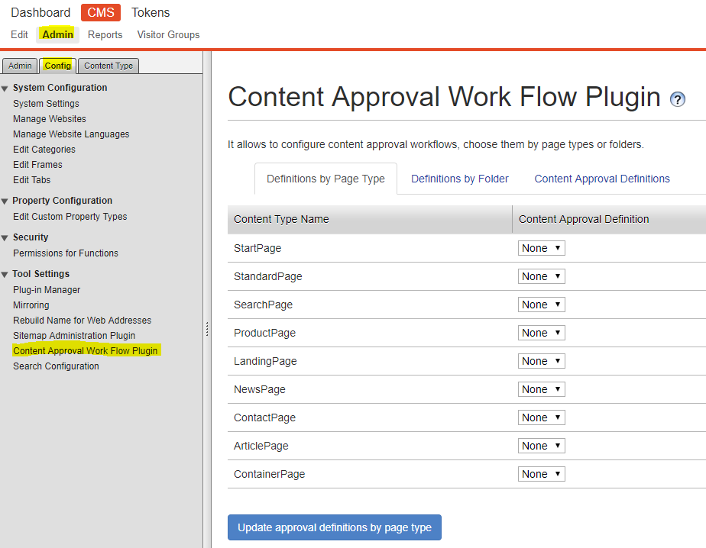
To create a new content approval workflow, you must go to the Content Approval Definitions tab and press the button Add new content approval definition
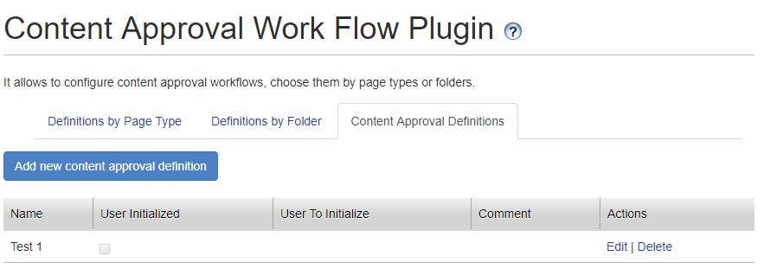
This will display a modal which will allow you to create a content approval workflow based on what you need.
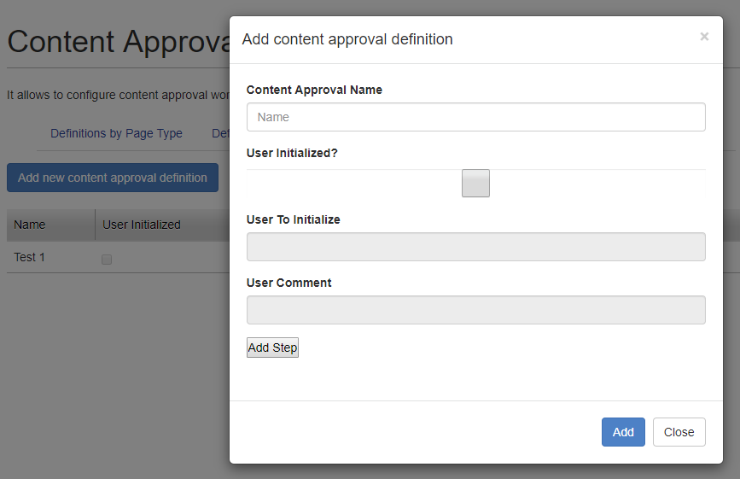
The description of each field is explained in more detail bellow:
Content approval name: name of the content approval, it is just a reference for the DDS item. Content approvals at the CMS level do not have names
User Initialized: checkbox to set if the content approval is initialized by the user or it is initialized by an editor (by default is not checked, editor initialized)
User to Initialize: if the checkbox user initialized is set to true, this field is enabled. It specifies the editor user that initializes the approval workflow when a client create a specific page or block inside a folder assigned with this content approval definition. This will make the workflow for the item created by the client to be at step 2 instead of step 1 because step 1 is initialized by the client. Therefore, a content approval workflow which initialized by a client, requires at least 2 steps
User Comment: if the checkbox user initialized is set to true, this field is enabled. It specifies the default comment that the editor user is going to set when the content approval is initialized by an item created by the client
To create a new step, you must press the add step button inside the modal. This will add one more field and two extra buttons inside the modal.
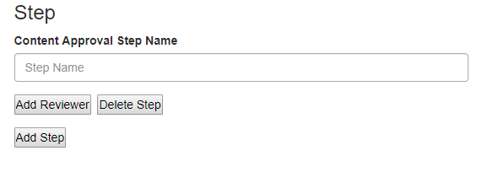
Content Approval Step Name: is the name of the step, this has a direct relation to the step name in the CMS UI for content approvals.
Delete Step: this button will remove the current step, including any reviewer that has been added to the step.
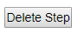

To create a new reviewer, you must press the add reviewer button which will add two more fields to handle the reviewer and a button to delete the current reviewer. You can add as many reviewers as you want per step
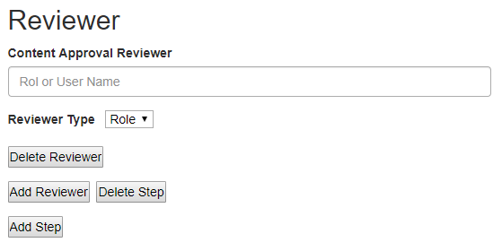
Content Approval Reviewer: is the user name of user role that is going to be used as reviewer of the step.
Reviewer Type: is the type of reviewer that is going to approve this step. If role is selected, the content approval reviewer field must use a role name. Otherwise, if user is selected, the content approval reviewer field must be a user name from the CMS
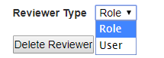
Delete Reviewer: this button will remove the current reviewer from the current step.
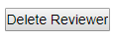
After everything is configured as expected you can press the Add button to create the content approval workflow, or press the close button to cancel the process
To edit or delete a previously create content approval workflow you can press the action links at the right side of each content approval definition row
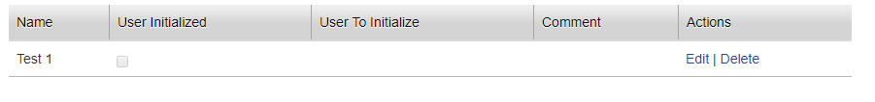
If the delete action link is pressed, a modal asking if you are sure, will be shown to the user. If confirmed, the content approval workflow will be removed. Consider that if the content approval workflow is being assigned to a page type or block type it will throw an error and will not remove the workflow definition
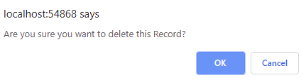
If the edit action link is pressed, the same modal to create a new content approval workflow will appear, but with the information related to that specific content approval definition
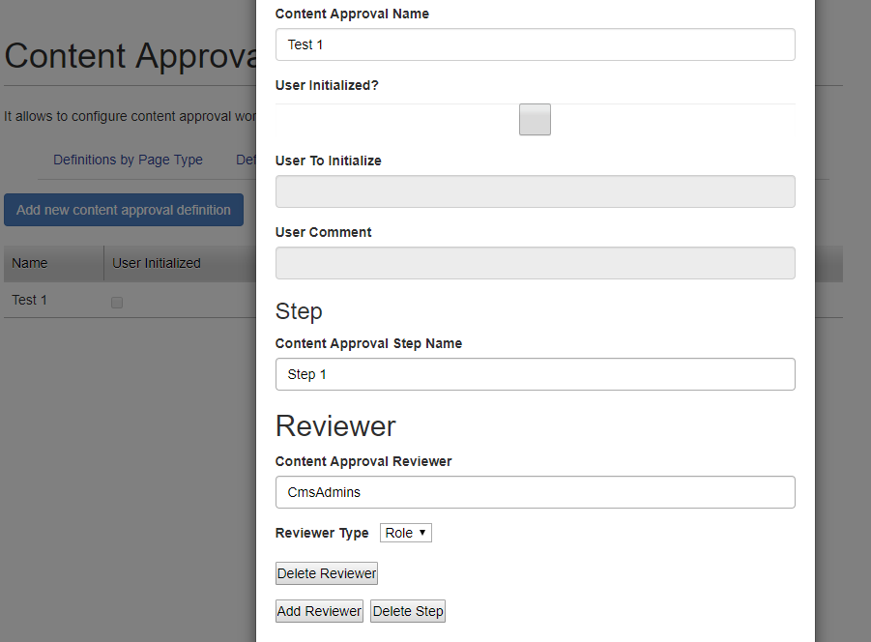
After the content approval workflow is created, you can visit the definitions by page type or definitions by folder tabs and assign the previously created workflow to any of the page types or folder. To do this, choose a page type or folder type you want and in the combo box next to its name choose the content approval workflow you want to use. After choosing them, you can press the button update approval definitions by page type or update approval definitions by folder type to save the information
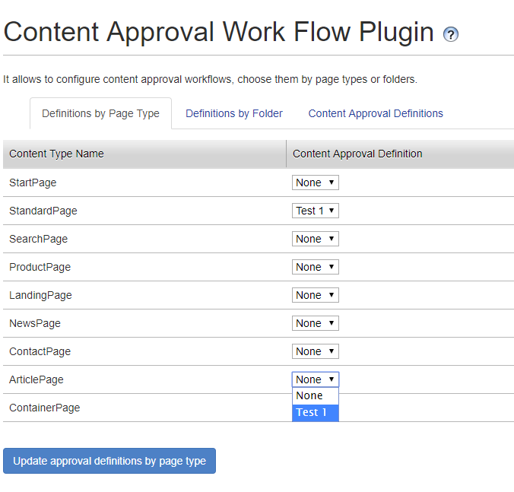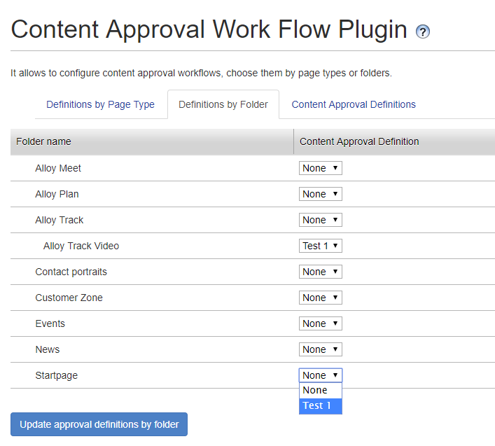
If the selection is saved successfully, it will show a success modal. Consider, that to save workflows to a page type, it requires to press the button update approval definitions by page type, if you use the button for folders, it will not save the data corresponding to page types.
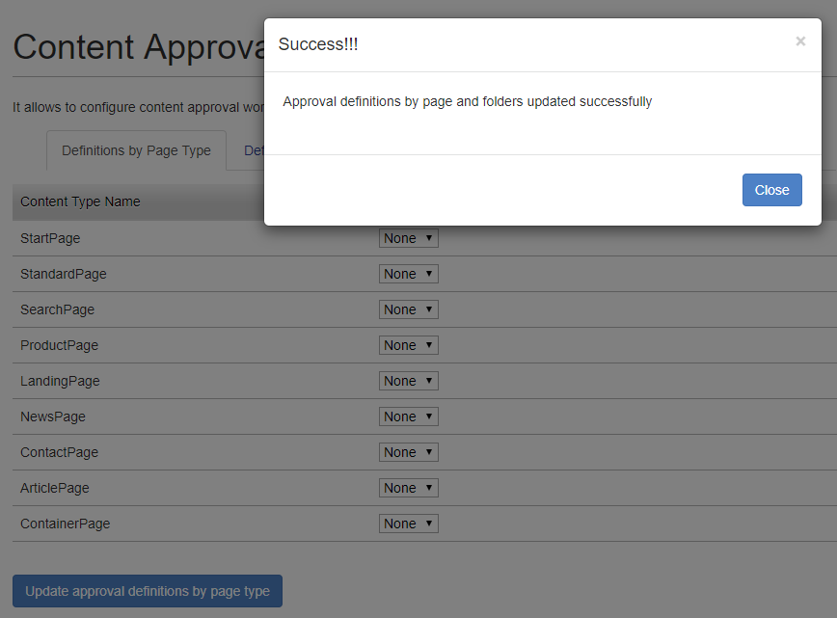
After the workflow is applied to a page type or folder, you can start creating pages of that type or blocks below the selected folder to see the content approval workflow in action. For instance, we can create a standard page anywhere below the home page
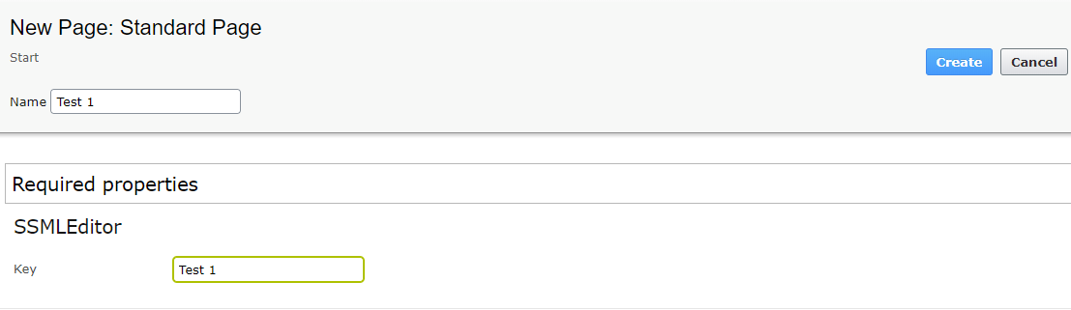
After creation, the page cannot be published immediately. Now, it requires a sequence of steps before being able to be published.
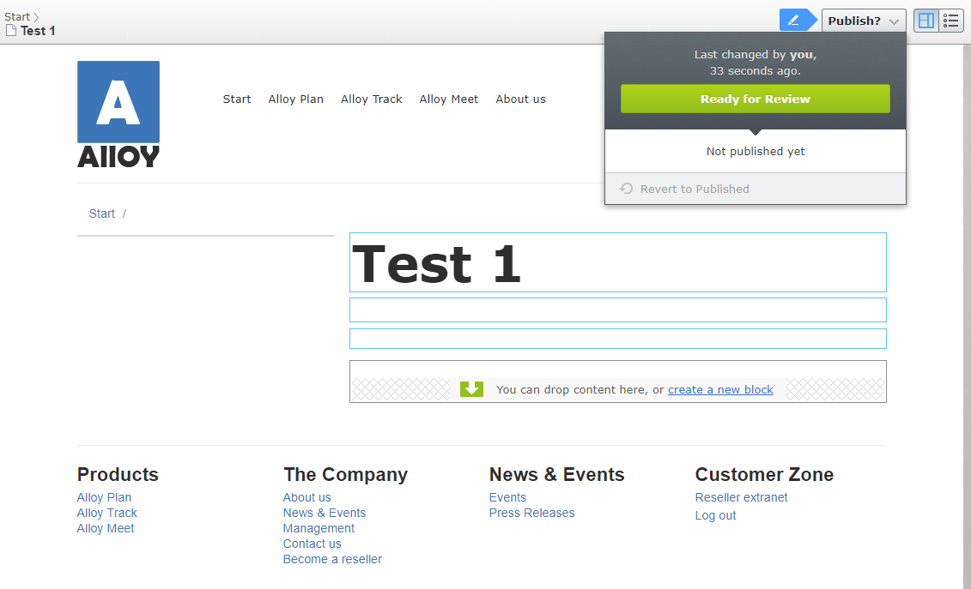

To check the current content approval workflow applied to this page. You can right click the created page, and then go to Edit Approval Sequence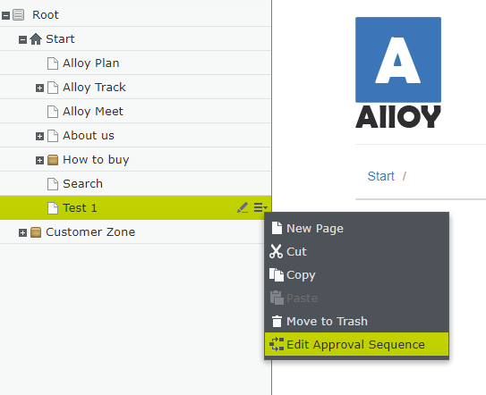
This will display the CMS UI for content approval sequences for this page, but with the content approval definition we defined for this page type
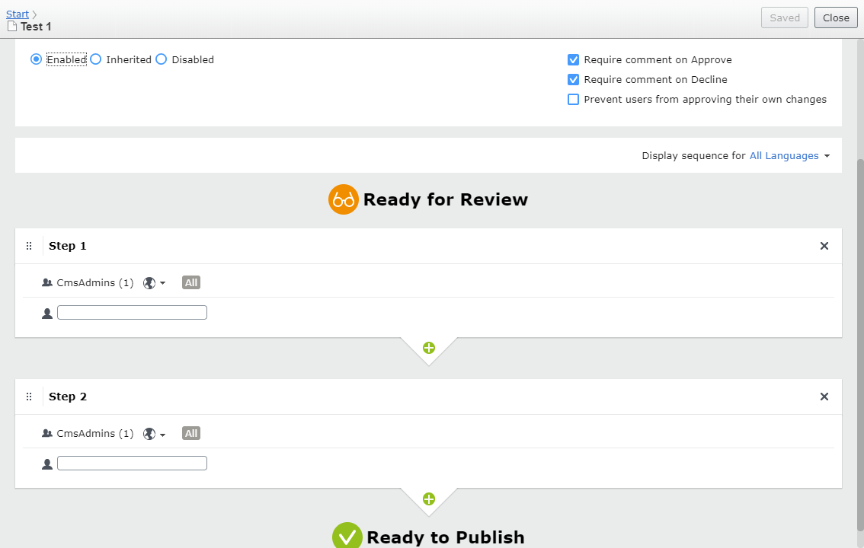
The same applies when we want to create blocks below a specific folder that we selected to be part of a content approval definition. In this case, we will create an Editorial Block below the folder Allow Track Video
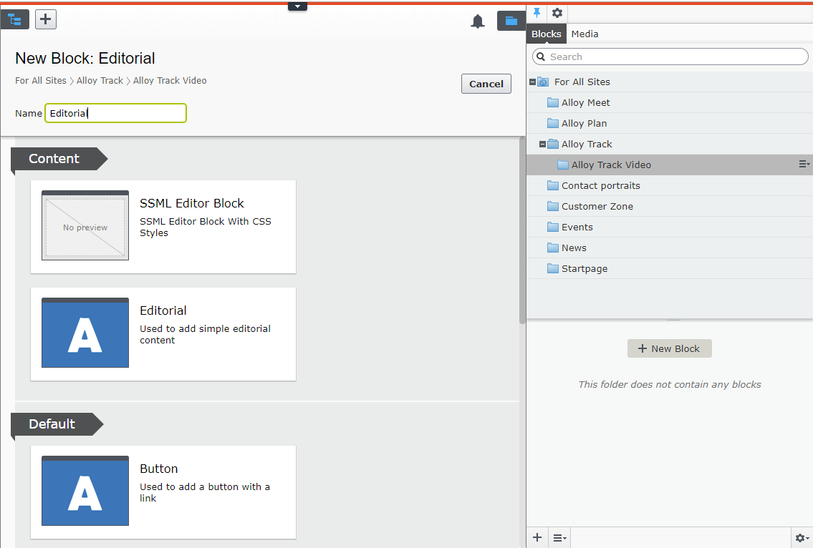
As in pages, the block cannot be published immediately. It now requires following a series of steps before being able to be published
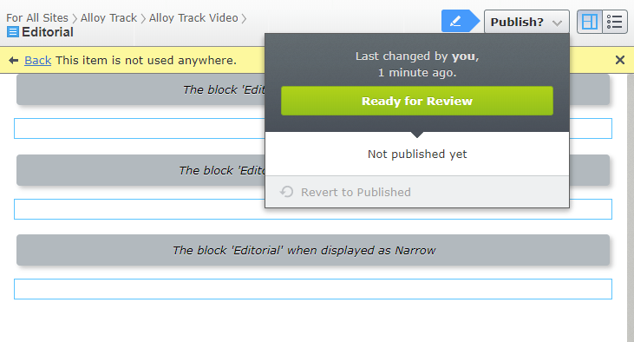
To see the current content approval workflow for the folder. You can right click in the folder and go to Edit Approval Sequence
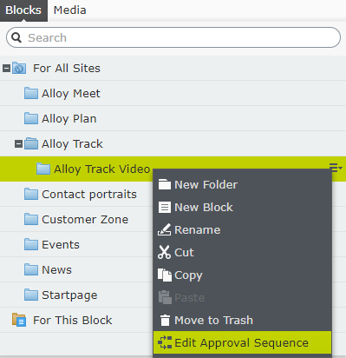
As in pages, this will display the current content approval sequence for this folder based on the content approval definition we created in the plugin
