Installation and Configuration Guide
Pre - Requirements:
- .NET Framework 4.7 or greater
- Castle.Core 4.2.1 or greater
- EPiServer.CMS.UI.Core 11.1.0 or greater
Installation:
Content Approval Plugin can be installed using the nuget package Verndale.Content.Approval.Plugin from the EPiServer nuget feed.
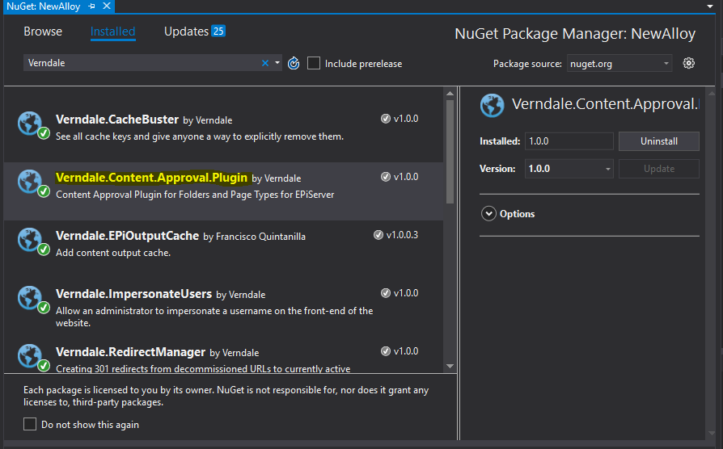
Configuration:
No extra configuration required

