User Manual
The Impersonate Users modules is intended to be used for administrators and developers with administration access rights in Episerver.
The Impersonate Users module will help developers or administrators to run the EPiServer website as other user. They will be able to experience it exactly as the end-user, which will aid in giving support when there are questions and troubleshooting when a user reports a problem that is difficult to recreate.
This administration tool does the following:
- Allow an administrator user to search for a user by various fields including username and email address.

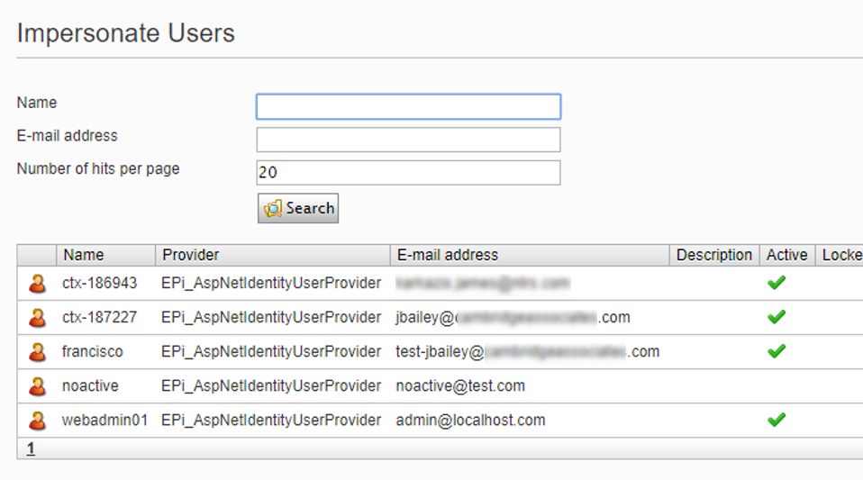

- Select the user which will open a new window to the front-end of the site, setting session user values and cookies by clicking on Impersonate link.

- Stop impersonating.

