User Manual
The Redirect Manager module is intended to be used for administrators and developers with administration access rights in Episerver.
This module provides URL redirection functionality to either an internal or external link when the page requested is not found. The redirect manager module helps you to keep the rank and search rating for pages which were replaced, moved or removed from your site.
This administration tool does the following:
- Allow content authors to add new redirects individually.

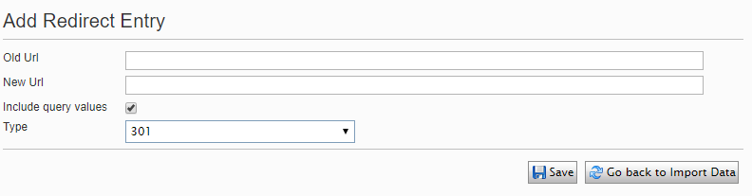

- Import redirects from a CSV file.
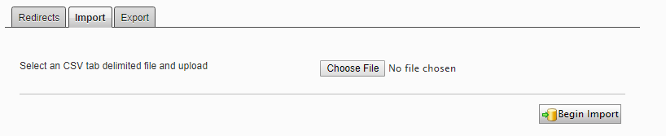
- Export redirects to a CSV file.

- Search redirects

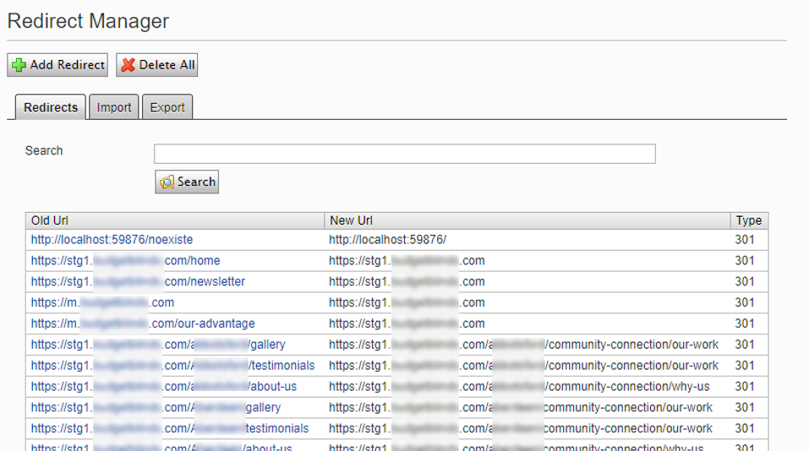

- Regex pattern is supported.
- Clear all redirects by clicking the Delete All button.
- Support to Relative or Absolute URLs.
- Specify if the redirect implements either 301 (Permanent Redirect) or 302 (Temporary Redirect) Rules.

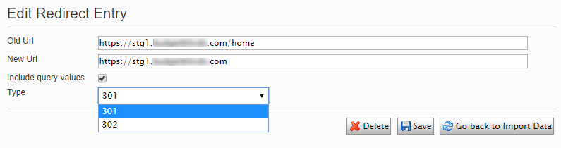

- Detail logging about redirects taking place.
