# User Manual

You should see a new “Tokens” option in the top navigation:

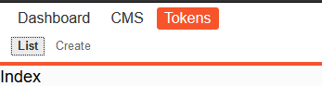

The list will be empty initially until you add entries. To do so, use the “Create” option.

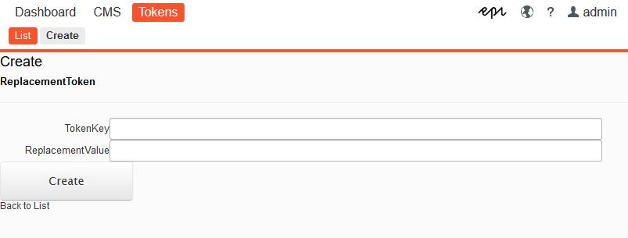

Once you create an entry it will be displayed under “List”

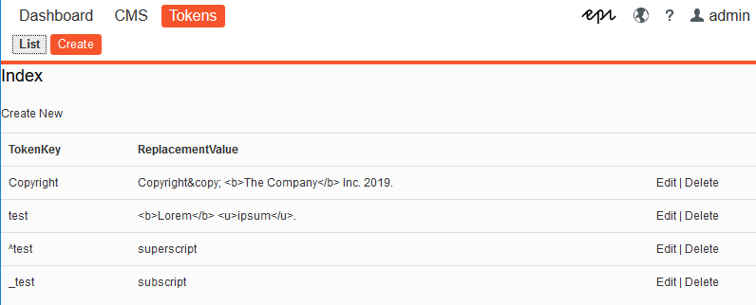

You have the option to “Edit” and “Delete” each entry.

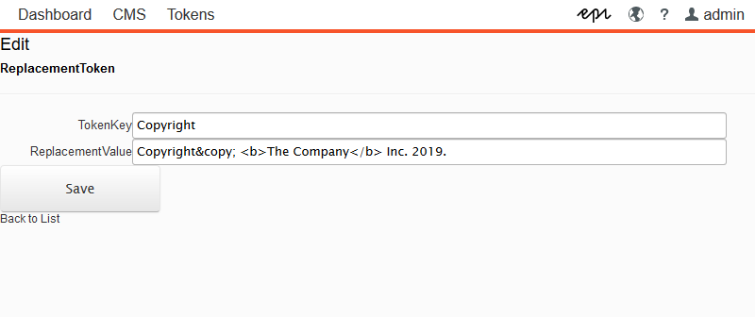

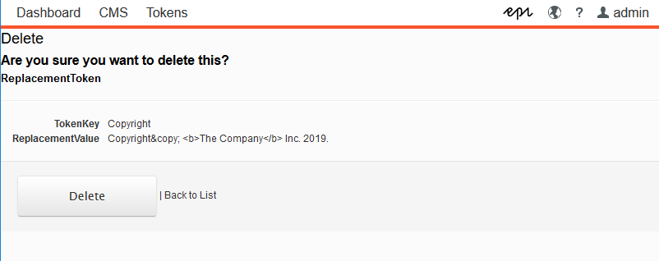

Once you have an entry created, you can use the “TokenKey” value wrapped in double square brackets. For example if your TokenKey is **Copyright** then you should use **[[Copyright]]** in any text field in the site.

Another thing to note is that if your TokenKey starts with ^ it will be a superscript. If it starts with _ it will be subscript.

