Installation and Configuration Guide

Pre - Requirements:

- .NET Framework >= 4.7
- Castle.Core >= 4.2.1
- EPiServer.CMS.AspNet >= 11.11.2
- EPiServer.CMS.UI.Core >= 11.18.0

Installation:

You can use nuget package manager to install Verndale.ReplacementTokens from the nuget.org nuget feed.
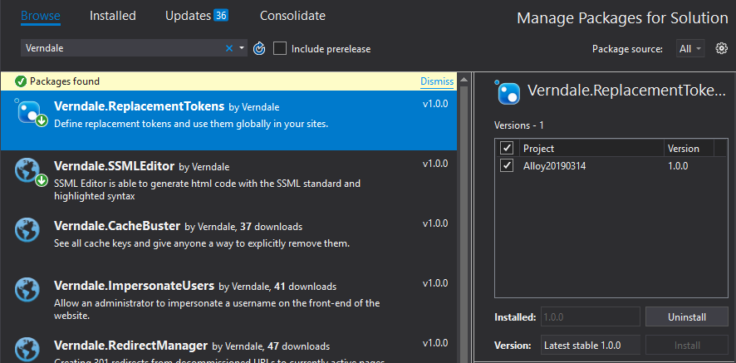

Configuration:

There is no configuration required for this module.

