User Manual
In order to use the Sitemap Robots Generator Plugin, and be able to generate dynamically the sitemap.xml and robots.txt files, you must first configure it by going to the Admin section of the CMS, to the Config Tab, Tool Settings and finally Sitemap Administration Plugin
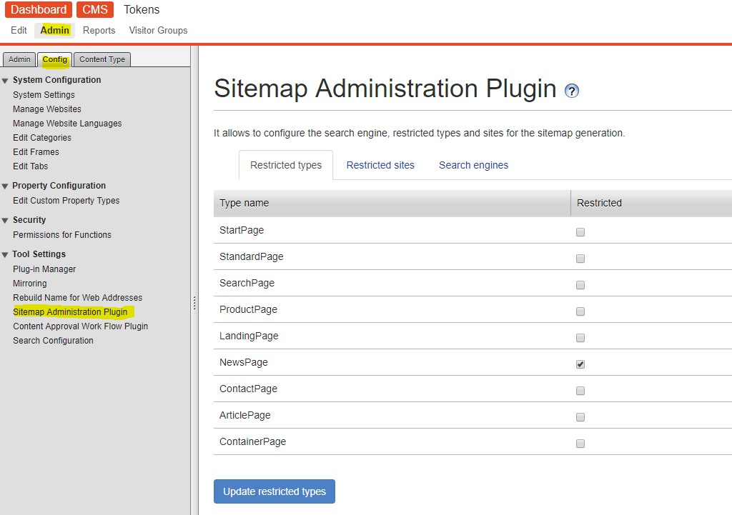
The first tab Restricted Types allows you to choose which page types are going to be excluded from the sitemap.xml file for all sites. In the example below, News Page type is not going to be include in the sitemap
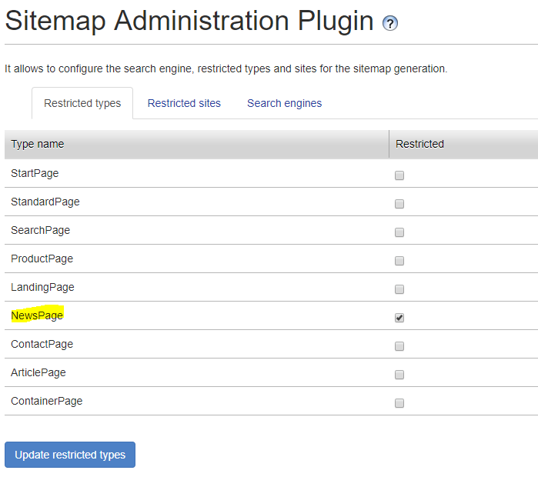
After choosing which page types are going to be restricted, you must press the button update restricted types to save the changes. Consider that if you go to another tab, changes not saved are going to be reverted. If the changes are saved successfully a modal will appear stating the result
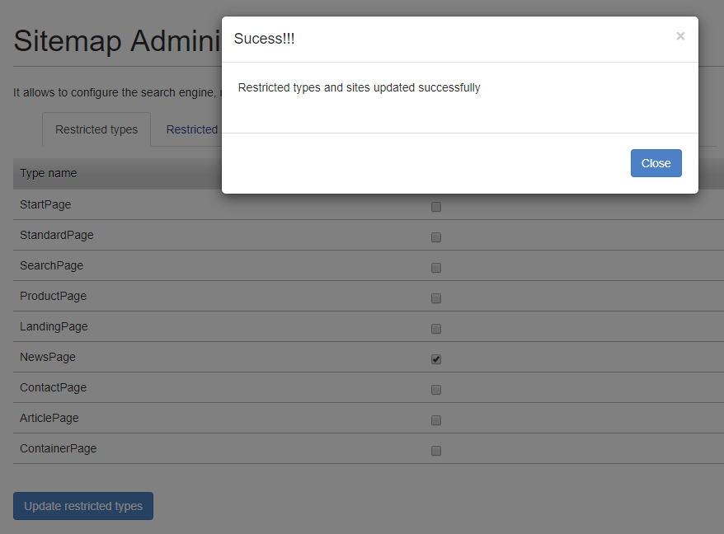
The second tab Restricted Sites allows you to choose which sites will generate their sitemap.xml and robots.txt files. In the example below, New Allow 1 will not generate those files.
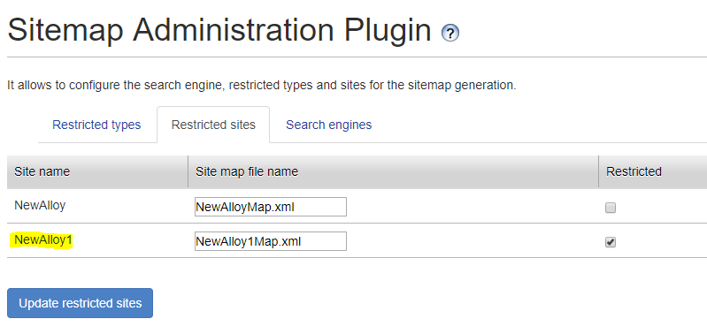
After choosing which sites are going to be restricted, you must press the button update restricted types to save the changes. If the changes are saved successfully a modal will appear stating the result
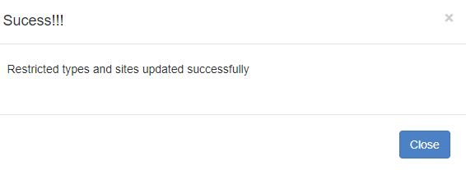
To create a new search engine which is going to be notified about the changes in the sitemap.xml and robots.txt files, you must go to the Search Engines tab and press the button Add new engine
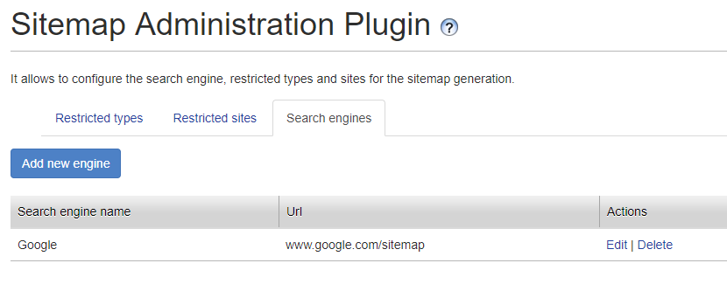
This will display a modal which will allow you to an engine based on what you need.
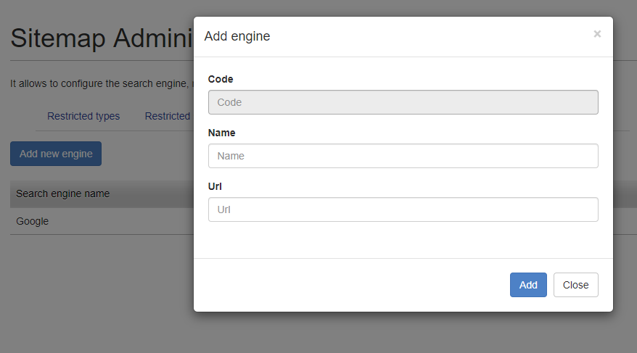
The description of each field is explained in more detail bellow:
Code: the code of the search engine, is a read only field

Name: name of the search engine, to be used as identifier
Url: URL that the plugin is going to call to refresh the sitemap.xml and robots.txt files
After everything is configured as expected you can press the Add button to create the search engine, or press the close button to cancel the process
To edit or delete a previously created search engine you can press the action links at the right side of each search engine row
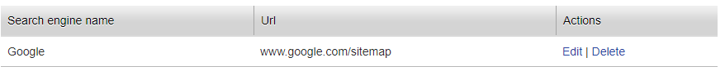
If the delete action link is pressed, a modal asking if you are sure, will be shown to the user. If confirmed, the search engine will be removed.
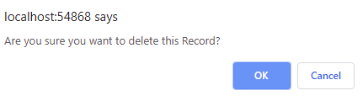

If the edit action link is pressed, the same modal to create a search engine will appear, but with the information related to that specific search engine
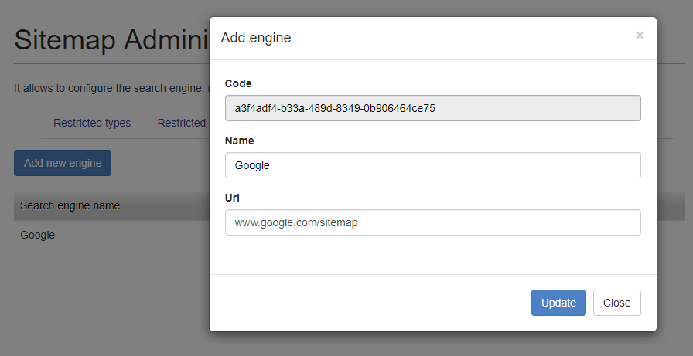
After everything is configured as you expect you can run the job located in Admin section, Admin tab, Schedule Jobs, Sitemap Generation to generate the sitemap.xml and robots.txt file for all sites.
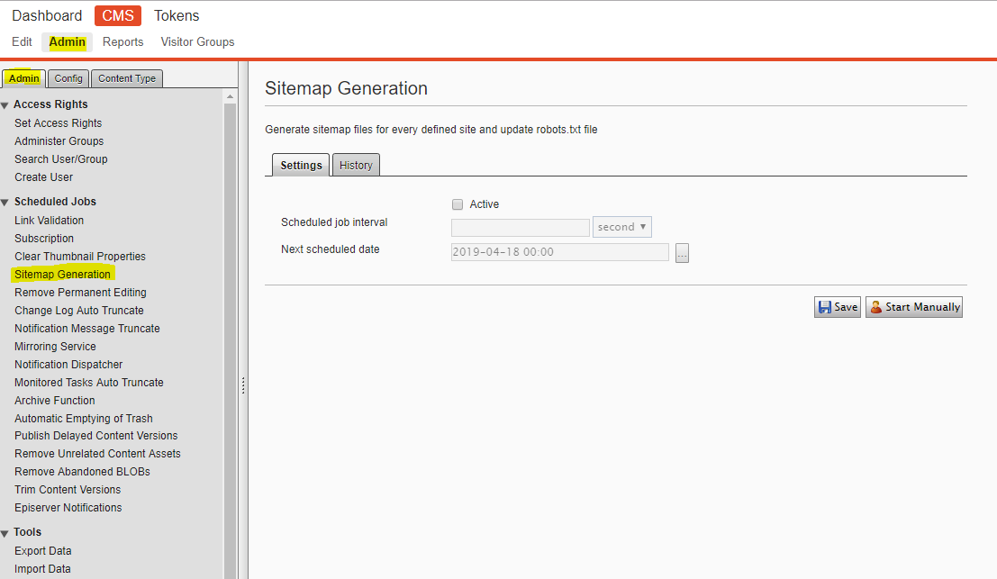
If you want to check the results of the job execution you can go to the history tab and see the information presented there.
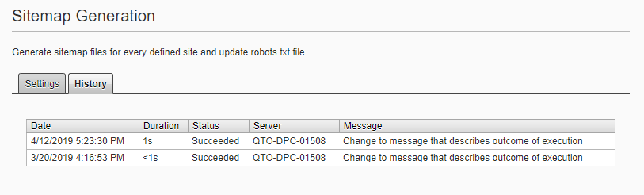
You can verify the generated sitemap.xml and robotst.txt files using the URLs: {domain}/sitemap.xml and {domain}/robots.txt respectively
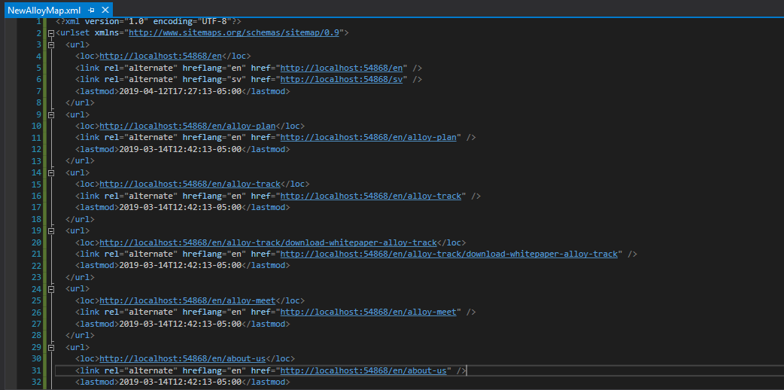
You can also generate the sitemap.xml and robots.txt files without previous configurations by using the dashboard plugin. The gadget allows the editor to choose which types and sites are going to be restricted.
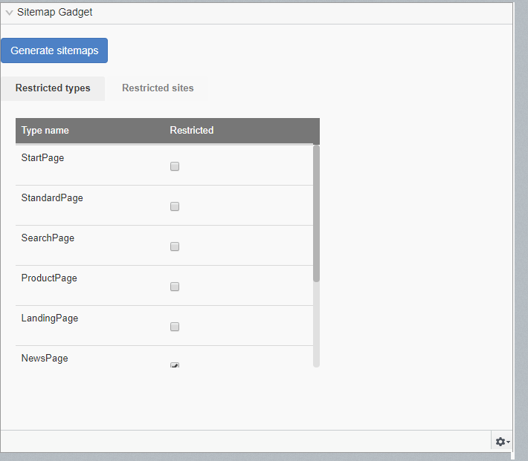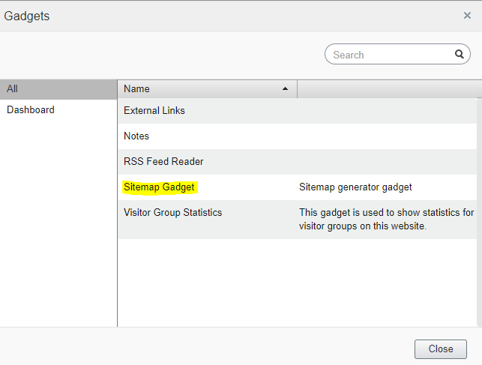

Press the Generate sitemap button to generate the sitemap.xml and robots.txt using the current configuration in the gadget. If everything is successful, a modal will appear stating the result and reload the page. You can verify the results using the previous mentioned URLs
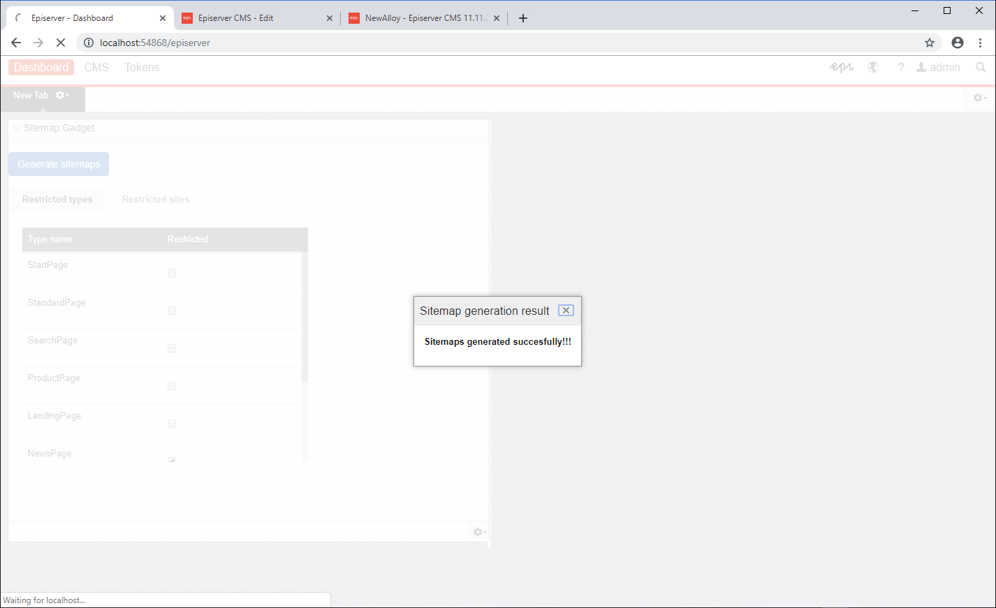
The “priority in site map” field, stablish the importance of item/page in the site and adds the xml tag priority inside the URL element in the sitemap.xml file, the “change frequency of page in site map” field specifies how often this page is updated with new content adding a changefreq xml tag inside the URL element. Both properties should be part of every page inside the navigation tab
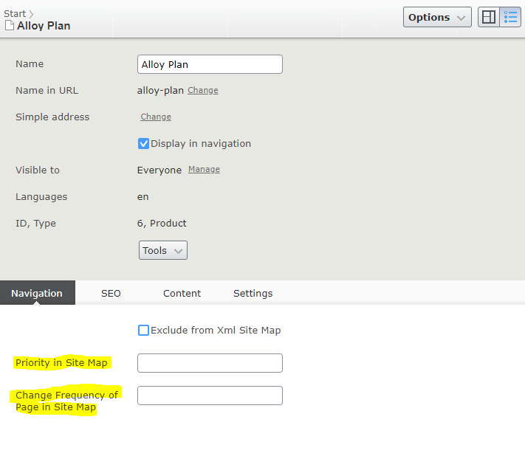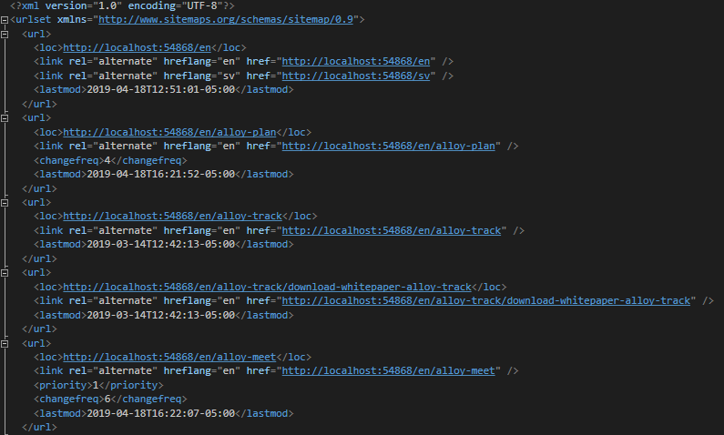

The field “exclude from xml site map” in the navigation tab, excludes the current page from the sitemap.xml file
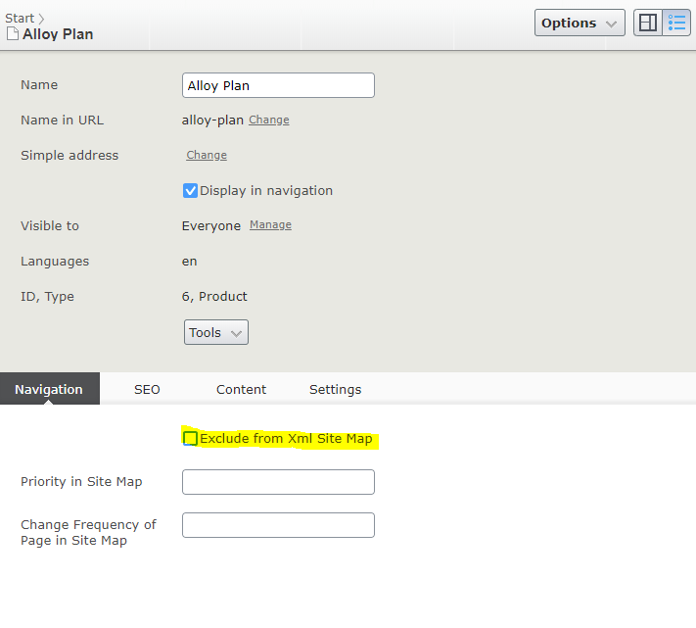
Finally, in the start page, SEO tab, the field “Robots” shows the content of the robots.txt file. It can be modified at any time and the URL that points to this file will reflect those changes
