Installation and Configuration Guide
Pre - Requirements:
- .NET Framework 4.7 or greater
- Castle.Core 4.2.1 or greater
- EPiServer.CMS.UI.Core 11.1.0 or greater
- Verndale.Sitemap.Robots.Generator.Core 1.0.0
Installation:
Sitemap Robots Generator can be installed using the nuget package Verndale.Sitemap.Robots.Generator and also nuget package Verndale.Sitemap.Robots.Generator.Core from the EPiServer nuget feed.
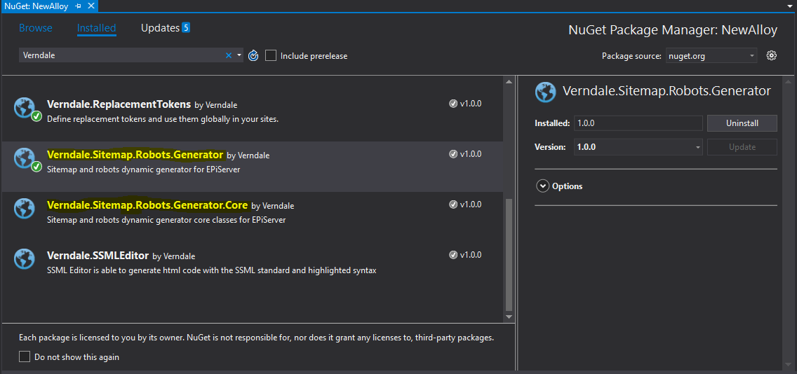
Configuration:
Verndale.Sitemap.Robots.Generator package contains the UI for the plugin, including admin plugin, dashboard gadget and http handlers
Verndale.Sitemap.Robots.Generator.Core package contains core classes to generate the sitemap.xml and robots.txt files
In order to enable some of the features in the plugin, it requires to modify your base page and start page with some fields we obtain by reflection to generate the files. These includes:
Common Page or Base Page
[Display(GroupName = "Navigation", Name = "Exclude from Xml Site Map", Order = 400)]
public virtual bool ExcludeFromSiteMap { get; set; }

[Display(GroupName = "Navigation", Name = "Priority in Site Map", Order = 500)]
public virtual string Priority { get; set; }

[Display(GroupName = "Navigation", Name = "Change Frequency of Page in Site Map", Order = 600)]
public virtual string ChangeFrequency { get; set; }

Start Page
[Display(Name = "Robots", Order = 1200, GroupName = "Metadata")]
[UIHint(UIHint.Textarea)]
public virtual string RobotsContent { get; set; }

In addition, if you are using web API in your project, you must add these lines in Global.asax.cs RegisterRoutes method

protected override void RegisterRoutes(System.Web.Routing.RouteCollection routes){
base.RegisterRoutes(routes);
routes.Ignore("sitemap.xml");
routes.Ignore("robots.txt");
}

Web config app keys:
Key | Description | Default Value
SiteMap_MAX_URLS | Limit the number of entries per file (Default 50000). If the threshold is reached, it generates and index file and several sitemap files | 50000
SiteMap_OutPutRobots_txt | Writes the sitemap path to the robots.txt file | true:1
Show_Trailing_Slash | Show a trailing slash at the end of every link | false
Show_Localized_URLS | Show localized URLs using lang href attributes with only one loc tag | true
Display_Localized_URLS_Separated | Display localized URLs separated, it will not use lang href attributes, instead it will show them as separate loc tags | false
siteMapConfig | Sitemap configuration file path | App_Config\  sitemap.config

Site map config keys:
Key | Description | Default Value
xmlNsTpl | Sitemap xml file namespace | http://www.sitemaps.org/schemas/sitemap/0.9
xmlNsLangTpl | Sitemap lang namespace | http://www.w3.org/1999/xhtml
productionEnvironment | Production environment, enables notification to search engines | false

