User Manual
The first step should be an admin setting up Project Flow Names. This is done in CMS > Admin. Then, In the Admin Tab, Tools section you’ll find “SSML Admin” link
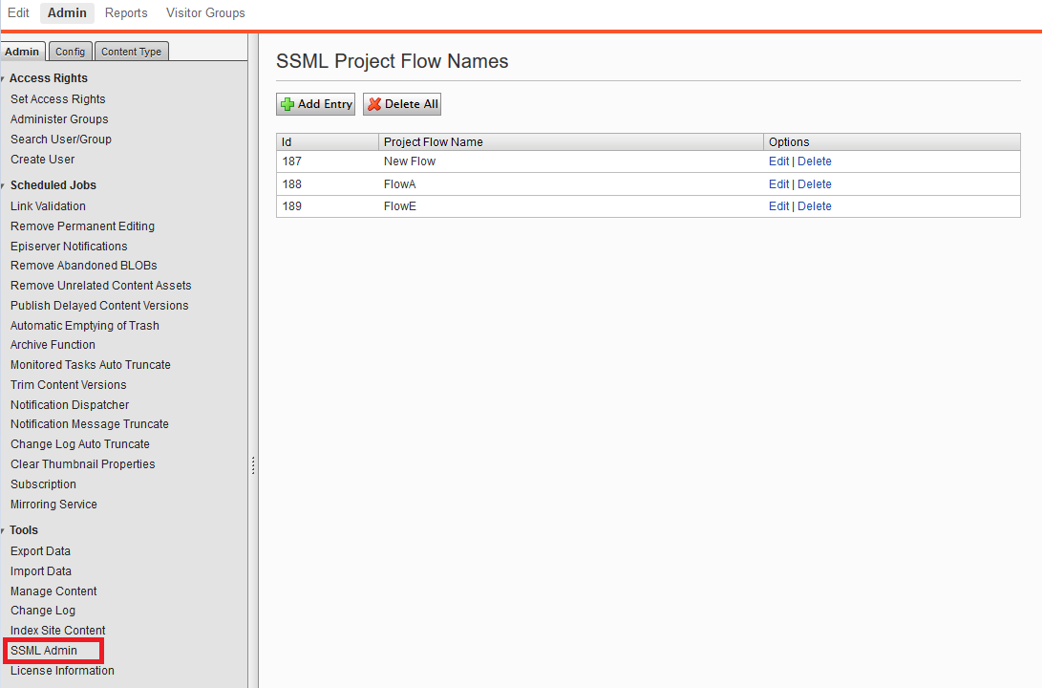
You can click on “Add Entry” at the top of the list. Add your test key and save. It should then display in the list.
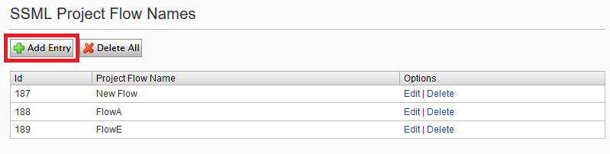
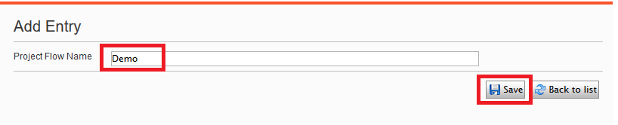
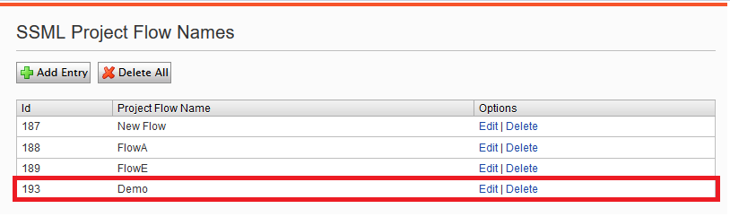
Add as many entries as required. These will allow you to retrieve all data related to those Names via a service: http(s)://{www.domain.com}/modules/SSMLContent?id={id}. Note that the project flow name (id) parameter is optional. Not adding it will display data for all SSML Editor blocks.
In order to use the SSML Editor in your project, as a developer you can add the SSML Editor block type as part of a page or block model in your code as shown below
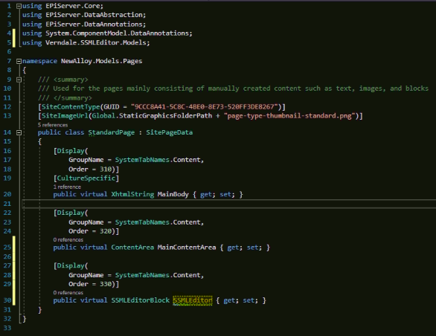
If you are an editor, you have the option to select it from the “Create a New Block” options.
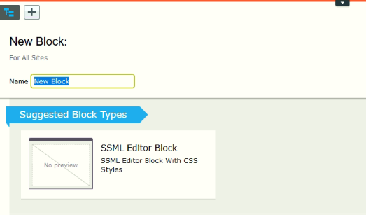
You will be prompted to set the Project Flow Name as it is required.
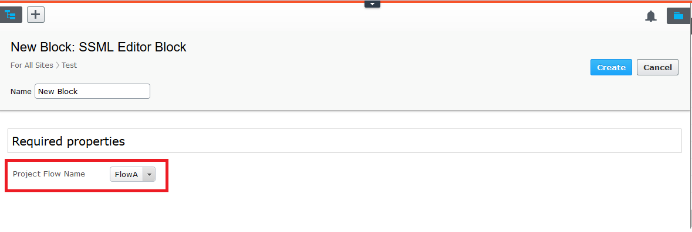
After the block was created or added to the model of a page or block, you can see the modified RTF editor with its corresponding buttons and a string key field
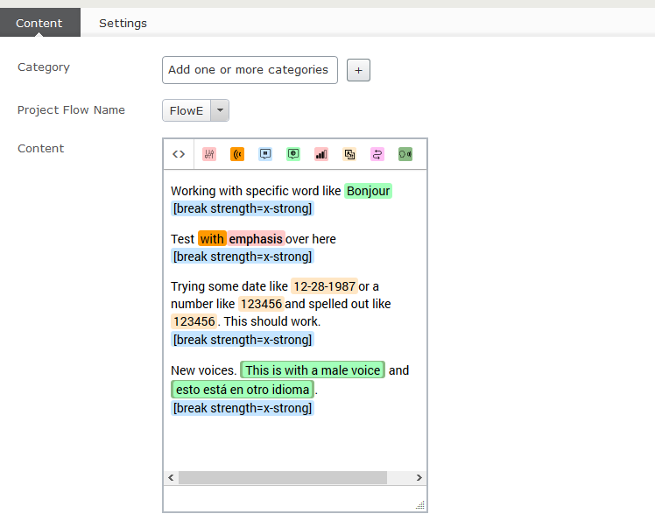
The buttons functionality of the SSML editor are explained below
Code button: shows the SSML code to be saved
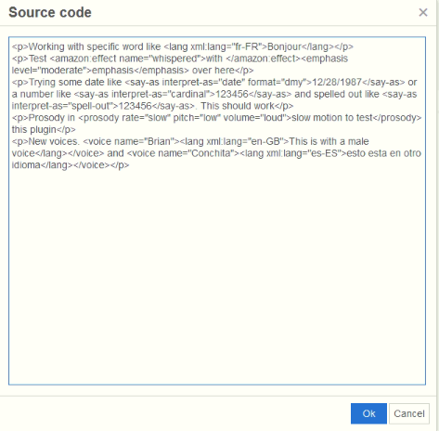
Emphasis button: applies an emphasis level for a specific phrase or word. You can choose among strong, moderate and reduced
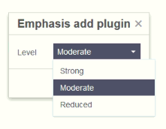
Effect button: applies and effect to a specific phrase or word. For the moment it only allows you to choose whisper and this effect works only for Alexa
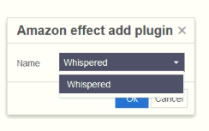
Break button: adds a break to the text/paragraph with a specific strength and a duration time in seconds. You can choose among none, extra weak, weak, medium, strong and extra strong as strength options and set the number of seconds the break is going to last.
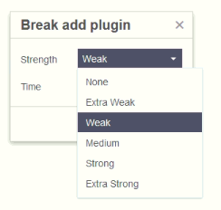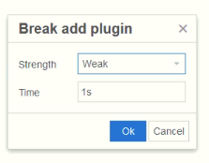

Lang button: allows a word to be pronounced in another language. You can choose among English (from US, India, Britain, Australia, Canada), German, Spanish, Italian, Japanese and French as language options.
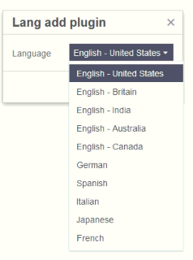
Prosody button: allows a word or phrase to be pronounced with a specific prosody by modifying its rate, pitch and volume. Rate options are: none, extra slow, slow, medium, fast, extra fast; Pitch options are: none, extra low, low, medium, high and extra high; Volume options are: none, silent, extra soft, soft, medium, loud and extra loud
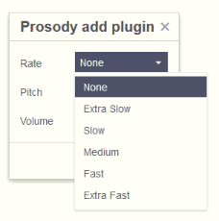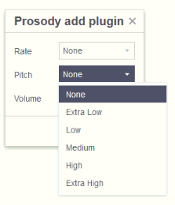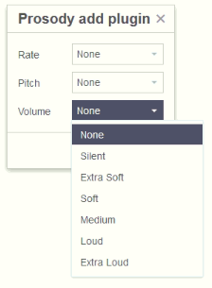

Say as button: allows a phrase to be interpreted as something specific like a number, date or address. If a date is selected, you can choose the format that should be used. The options for interpret as are: spell out, cardinal, ordinal, digits, fraction, unit, date, time, telephone, address, interjection and expletive. For format date you have: MDY, DMY, YMD, MD, DM, YM, MY, D, M, Y where M means month, D day and Y year
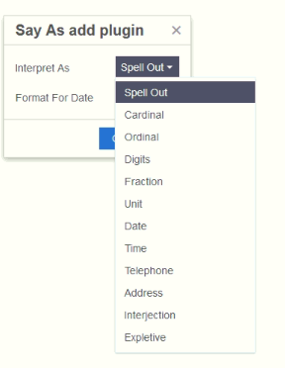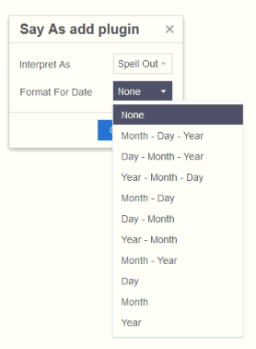
Sub button: replace the text value of a specific word or phrase for another one. For instance, the text can be magazine, but the sub can be mag, which is what the assistant is going to say.
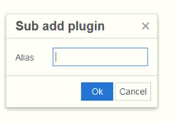

Voice button: allows the assistant to say a phrase in a different language from the default one. You can choose among English (8 American voices, 2 Australian voices, 3 British voices, 2 Indian Voices), 3 German voices, 2 Spanish voices, 2 Italian voice, 2 Japanese voices and 3 French voices.
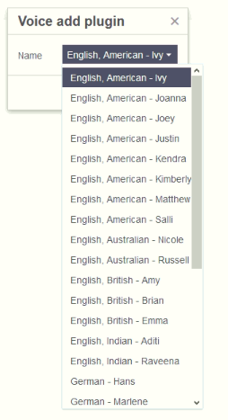
To add a SSML tag to a phrase or word you must first mark the text you want to add the tag, press one of the explained buttons in the tool bar, choose the options you want from the modal and press the ok button. If you want to modify a specific SSML tag to a phrase or word you must first mark the text you want to modify that uses the tag, or use the tag link at the bottom of the RTF editor, press the corresponding tag button in the tool bar, choose the new options you want from the modal and press ok
In addition to the buttons in the extend RTF editor, there is a dropdown field “Project Flow Name”. This value will be the identifier when calling the web service to get the SSML content of the block via the id parameter.
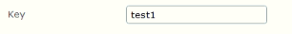
For instance, if the block key is test 1, we can call the web service using the URL: http(s)://www.domain.com/modules/SSMLContent?id=FlowA and this will return the content of all SSML blocks with that project flow name.
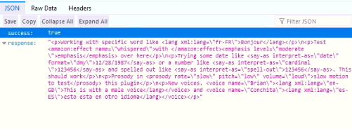
If we want to get all content from all SSML Editor blocks in the site, we do not send the id parameter as part of the URL of the web service. For example, calling this URL http(s)://www.domain.com/modules/SSMLContent will return the following result
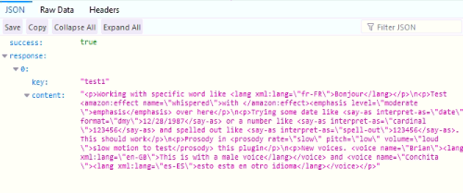
The web service will always answer with a JSON response

