Installation and Configuration Guide
Pre - Requirements:
- .NET Framework 4.7 or greater
- Castle.Core 4.3.1 or greater
- EPiServer.CMS.TinyMce 2.0.0 or greater
Installation:
SSML Editor can be installed using the nuget package Verndale.SSMLEditor from the EPiServer nuget feed.
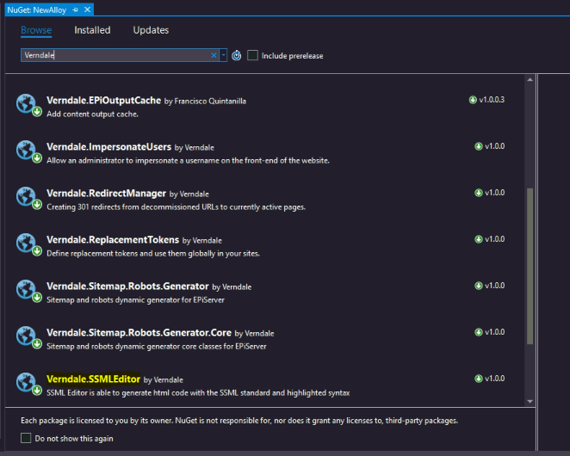
Configuration:
No extra configuration required

