from
Radio + Digital
Elevate your business
<Insert station/group logo>

Advertisers need to reach consumers where they are, and today, more than 60% of consumers’ daily media time is spent interacting with digital or radio. With an integrated advertising approach, you can manage cross-channel advertising processes, budgets and objectives holistically, reducing inefficiencies that might come from having to work with multiple teams or platforms.

Third-party digital from <insert station/group name>

By offering airtime and digital advertising solutions under the same roof, your business can:
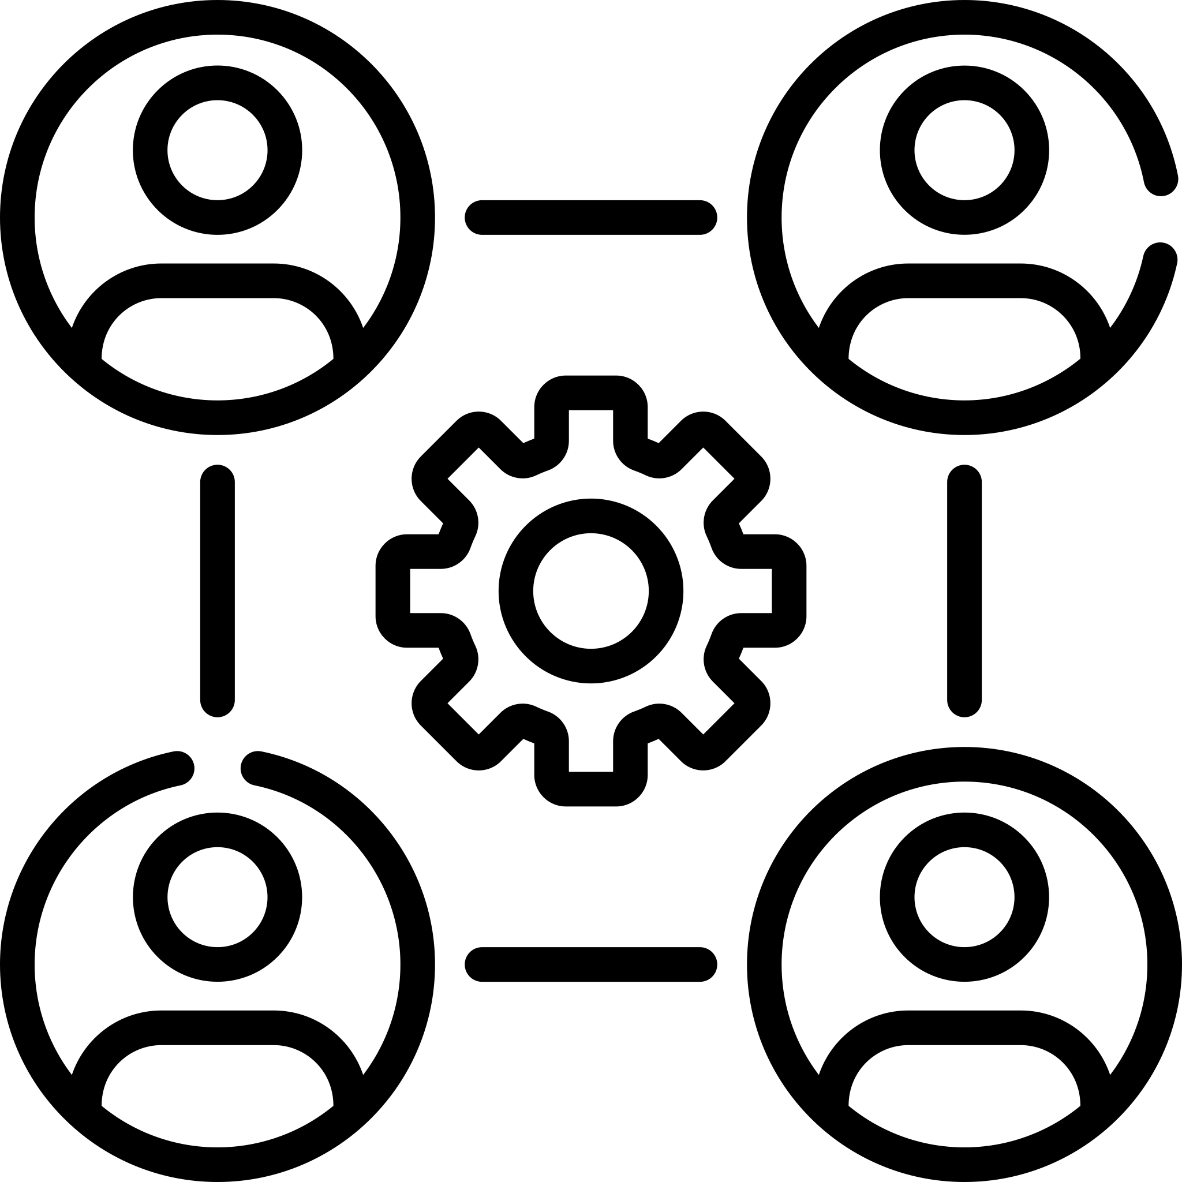
Save time with a consolidated approach
We will seamlessly handle your airtime and digital needs from one platform, one process and one team.

Get guidance from a trusted partner
We understand your business and target audience, and we will collaborate with you to define an integrated advertising campaign that meets your goals.

Be confident with full transparency
Upfront you will know how much money is allocated to each tactic, and once the digital campaign is live, you will know where every digital ad impression ran.

Save costs with less vendors
Drive higher ROI by consolidating airtime and digital campaigns through one vendor, reducing overall fees your business has to cover.

Cover awareness to purchase
Share a consistent brand message across media channels to reach consumers throughout their buying journey.

Our digital tactics include:
- Targeted display and video
- Geofencing and video geofencing
- Over-the-top (OTT)/connected TV (CTV)
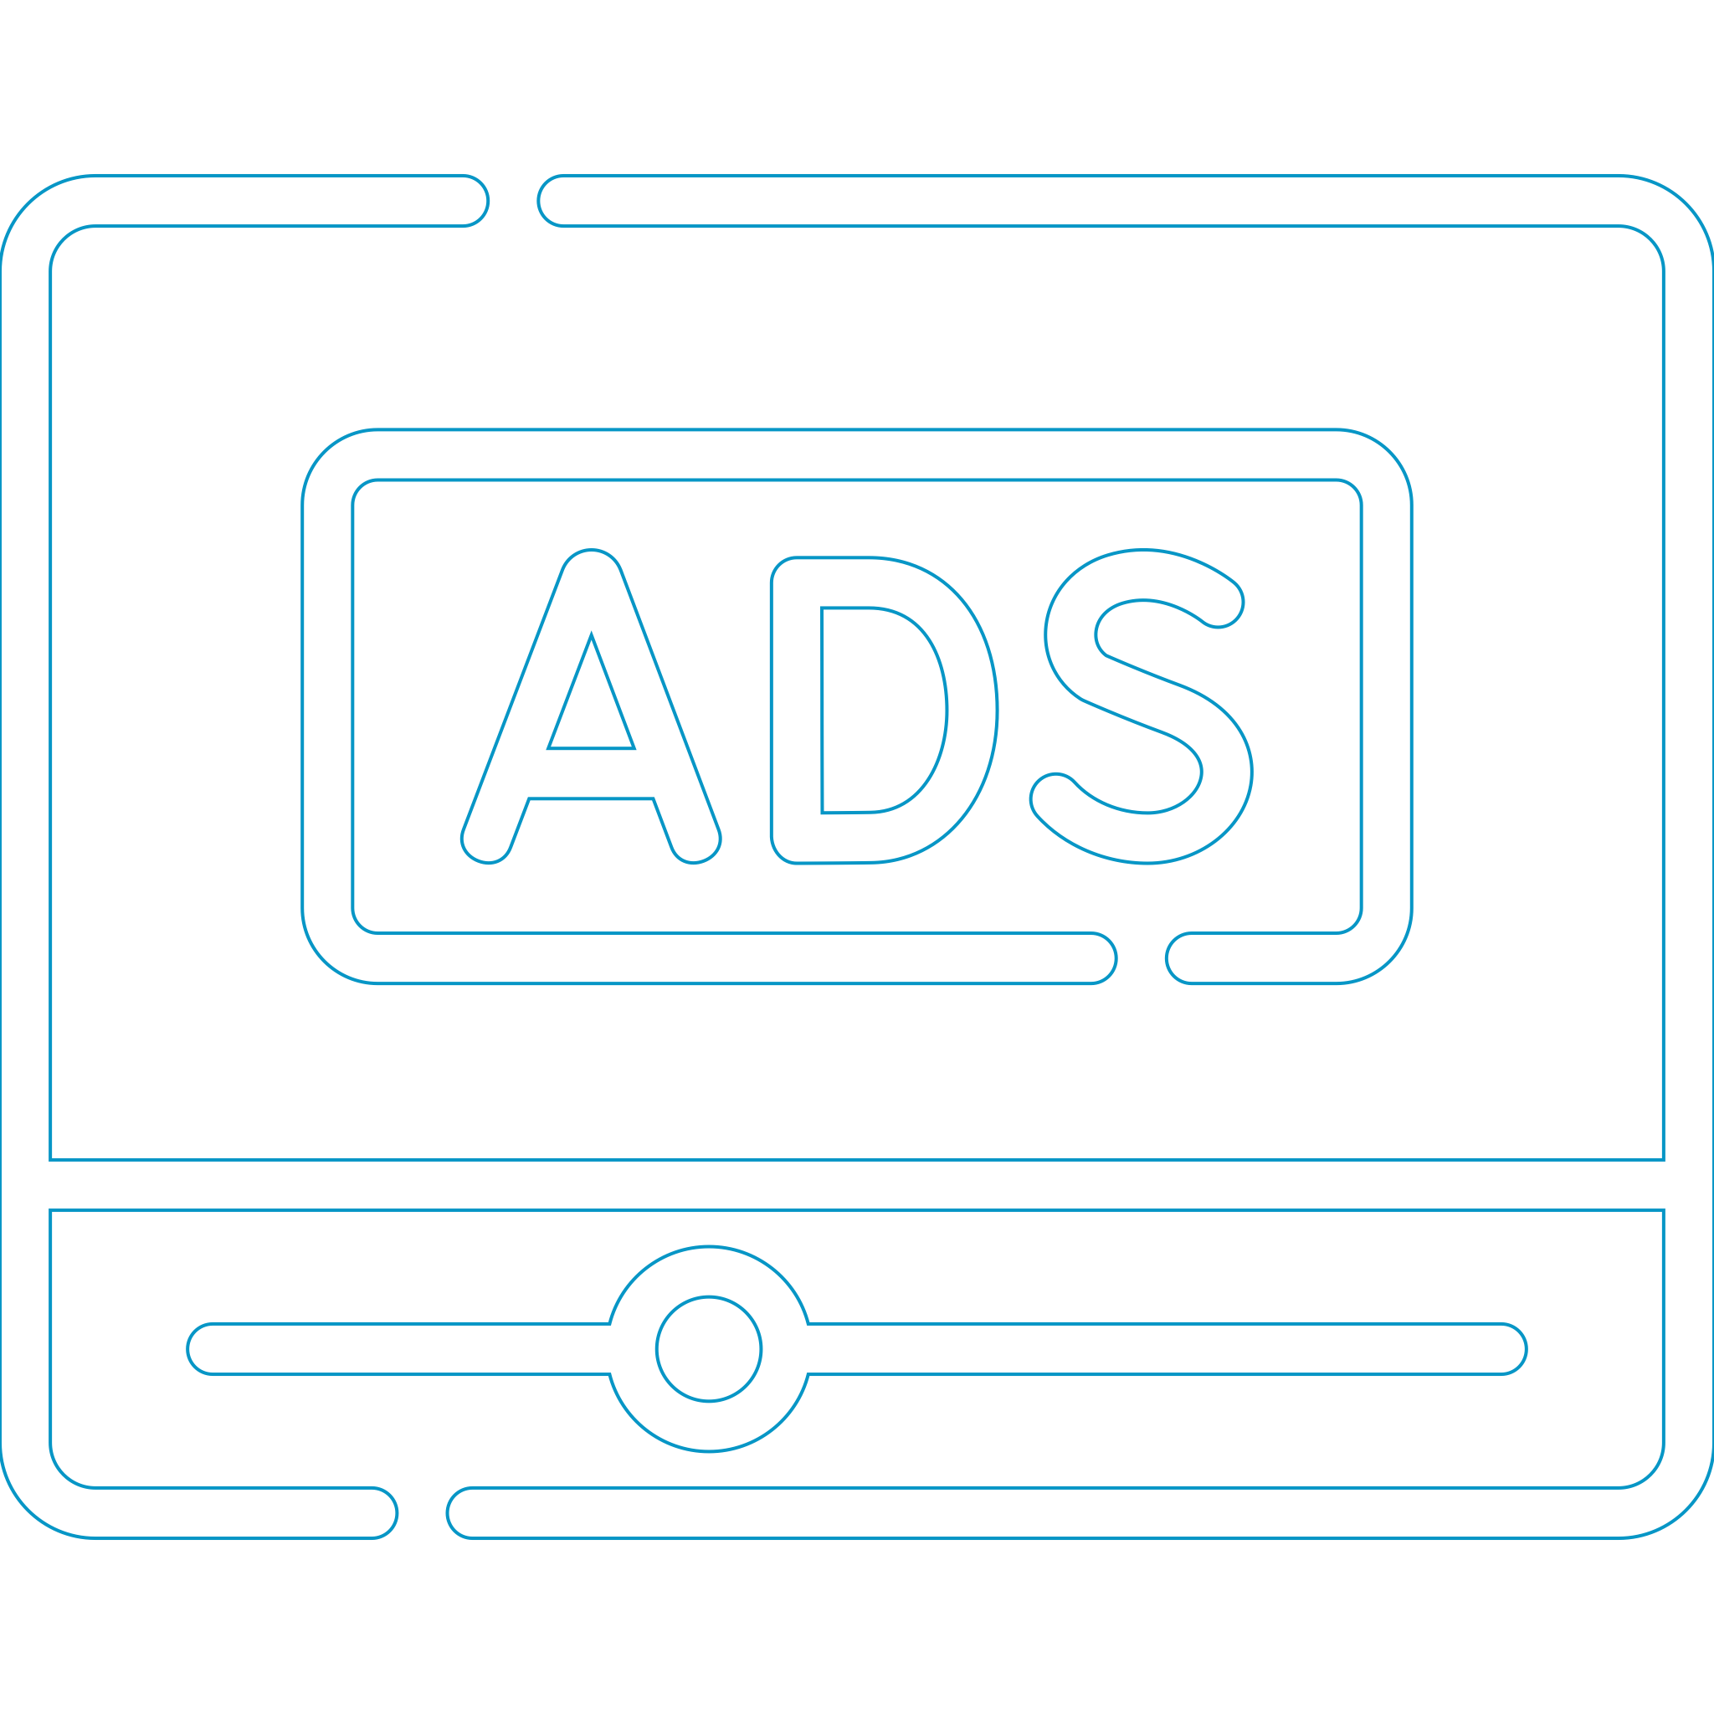
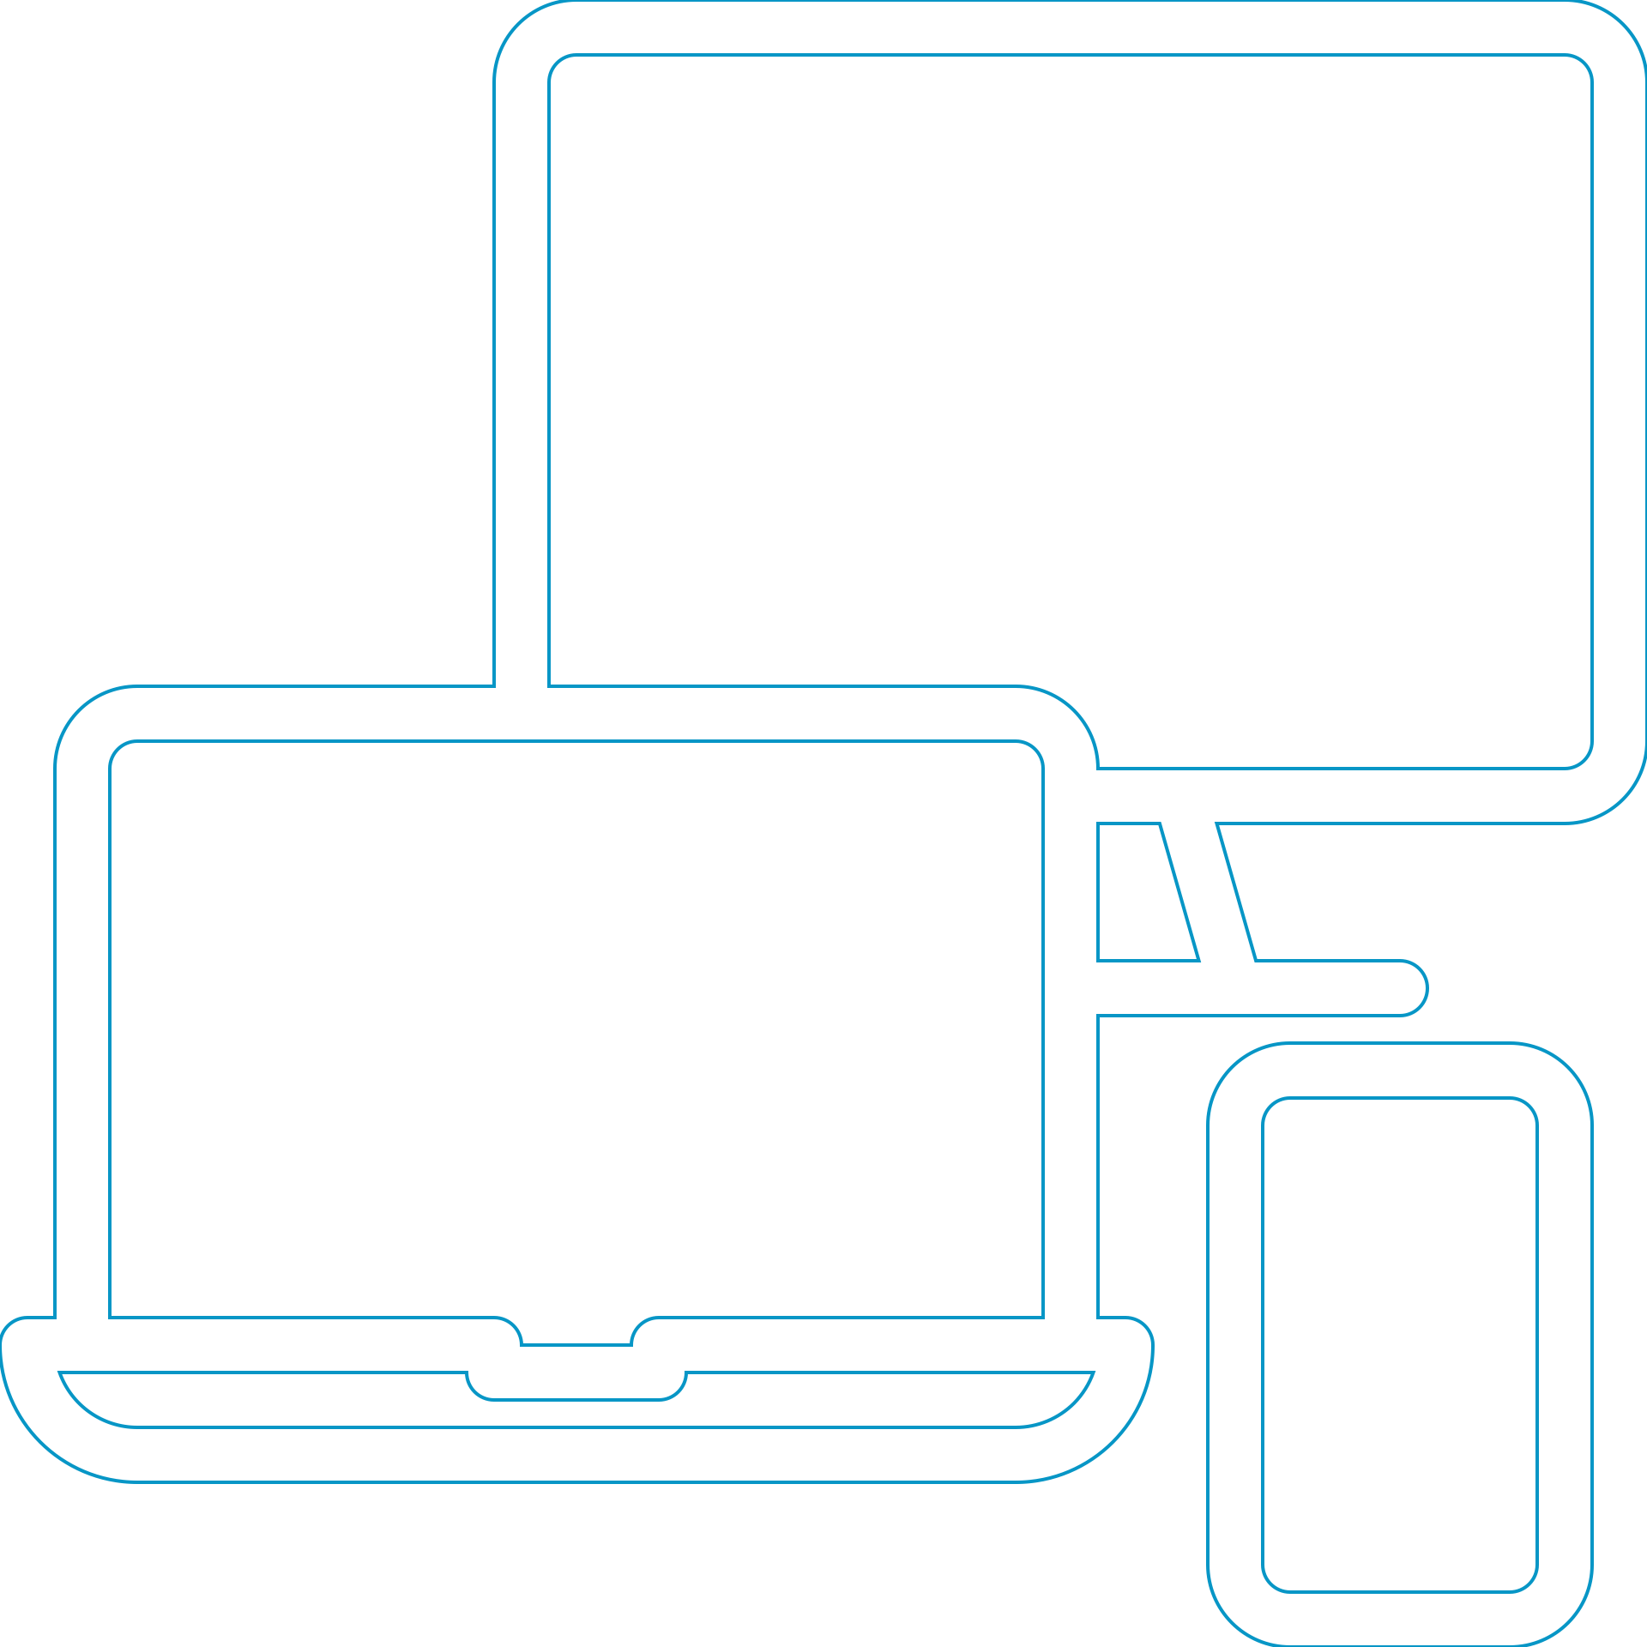
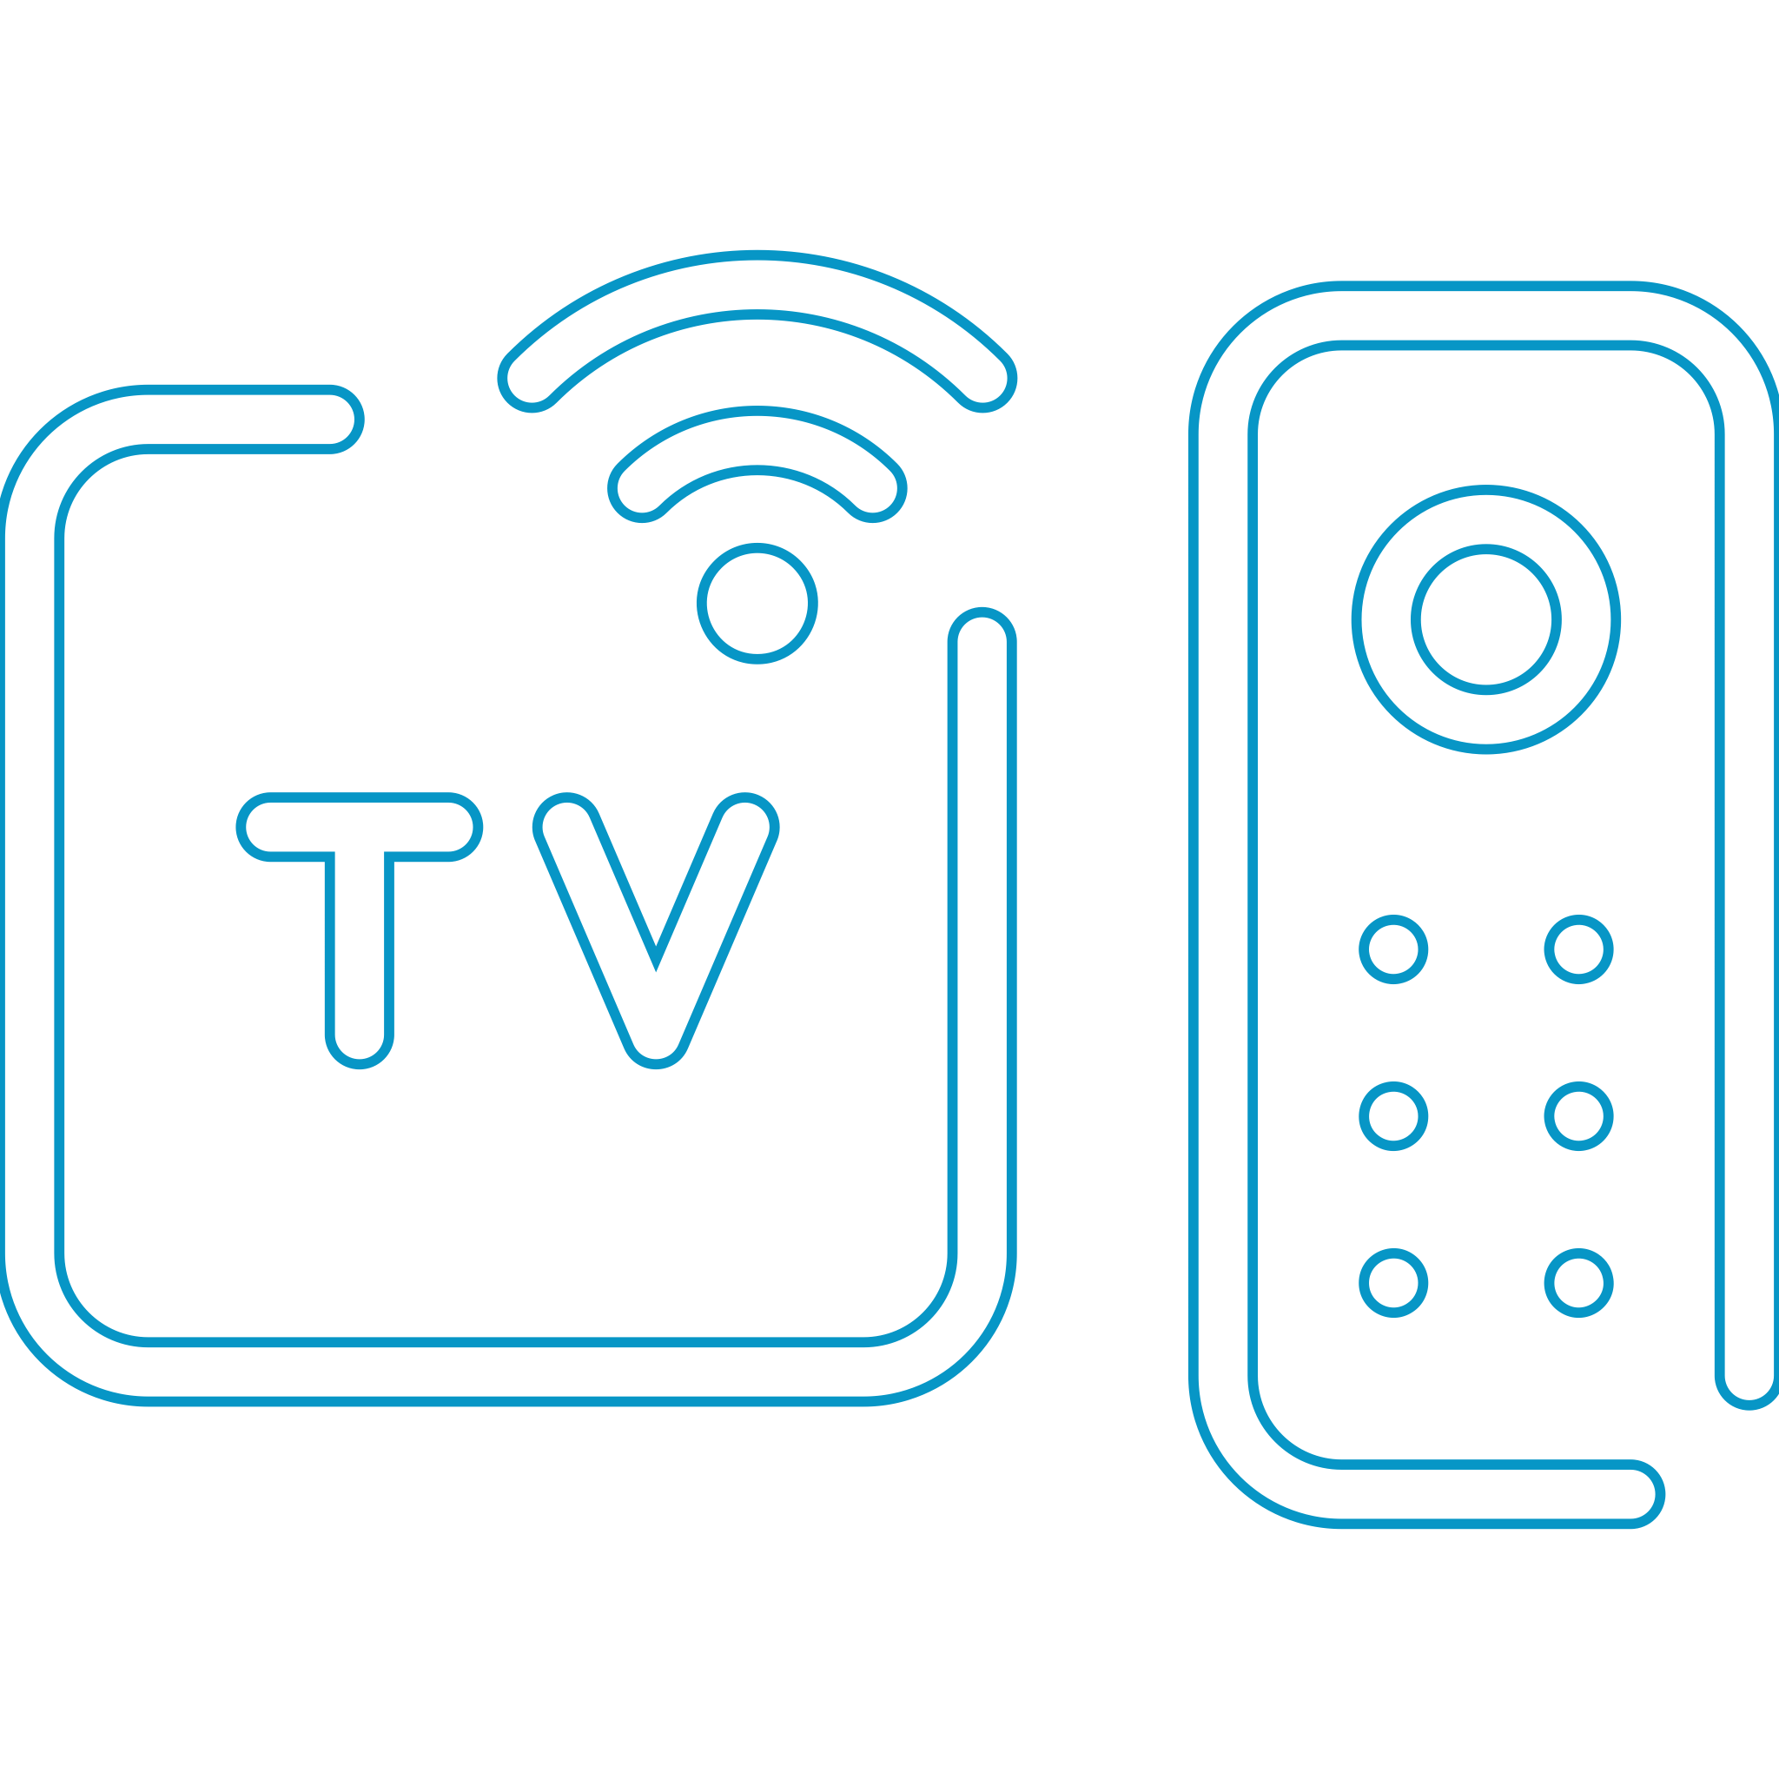

Source: eMarketer, 2019

