from
Digital Products

<Insert station/group logo>

From awareness to conversion, <insert station/group name> has an advertising tactic to meet your campaign objective.

Third-party Digital

Display  Static or animated banner ads in various sizes  shown to people on computers and mobile devices. | Connected TV (CTV)/Over-the-top (OTT)  Video commercials played before, during or after long form content on televisions or internet-streaming devices.
Video  Video commercials played before, during or after content shown to people on computers and mobile devices. | 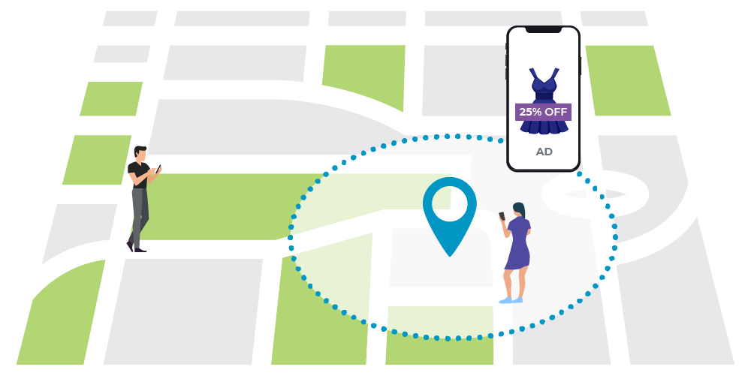  Geofencing and video geofencing  Display or video ads shown to people within a defined virtual fence and on devices with location services enabled.

Advertiser Objective: Awareness Consideration Conversion

Display creative development services available
We will design them in the most frequently used display ad sizes.

from
Digital Products

<Insert station/group logo>

Owned & Operated
<insert available offering 1: screenshots>  <insert available offering 1: header>  <insert available offering 1: body text> | <insert available offering 2: screenshots>  <insert available offering 2: header>  <insert available offering 2: body text>
<insert available offering 3: screenshots>  <insert available offering 3: header>  <insert available offering 3: body text> | <insert available offering 4: screenshots>  <insert available offering 4: header>  <insert available offering 4: body text>

