Third-party Digital Advertising Website Copy
and Image Templates
The website copy and images below are designed to support your launch of third-party digital advertising and are designed to be included on your website. Please feel free to adjust them to make them your own. We’ve noted areas for required customization in yellow.

Website Copy
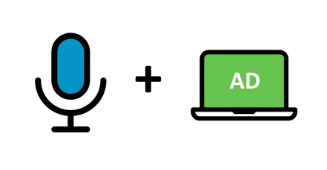
Why should you add digital campaigns to your airtime lines with <insert station/group name>?
- Save time - We will handle your airtime and digital needs from one platform, process and team.
- We know our community – We will collaborate with you to define an integrated advertising campaign that meets your goals and will resonate with members of our community.
- Save costs - Reduce overall fees and improve ROI by consolidating airtime and digital campaigns through one vendor.
- Target the entire buyer’s journey – Using both digital and airtime you can reach buyer’s throughout their entire shopping experience from awareness to purchase.

Common digital advertising tactics
Targeted display  Static or animated banner ads in various sizes shown to people on computers and mobile devices. | Use Case Example:  A restaurant wants to promote new cooking classes they are offering.  First, create an ad that highlights the new cooking classes and includes a call to action (CTA) for people to register for the class. Then, use demographic and interest targeting to reach local females, 25-34, who enjoy cooking.

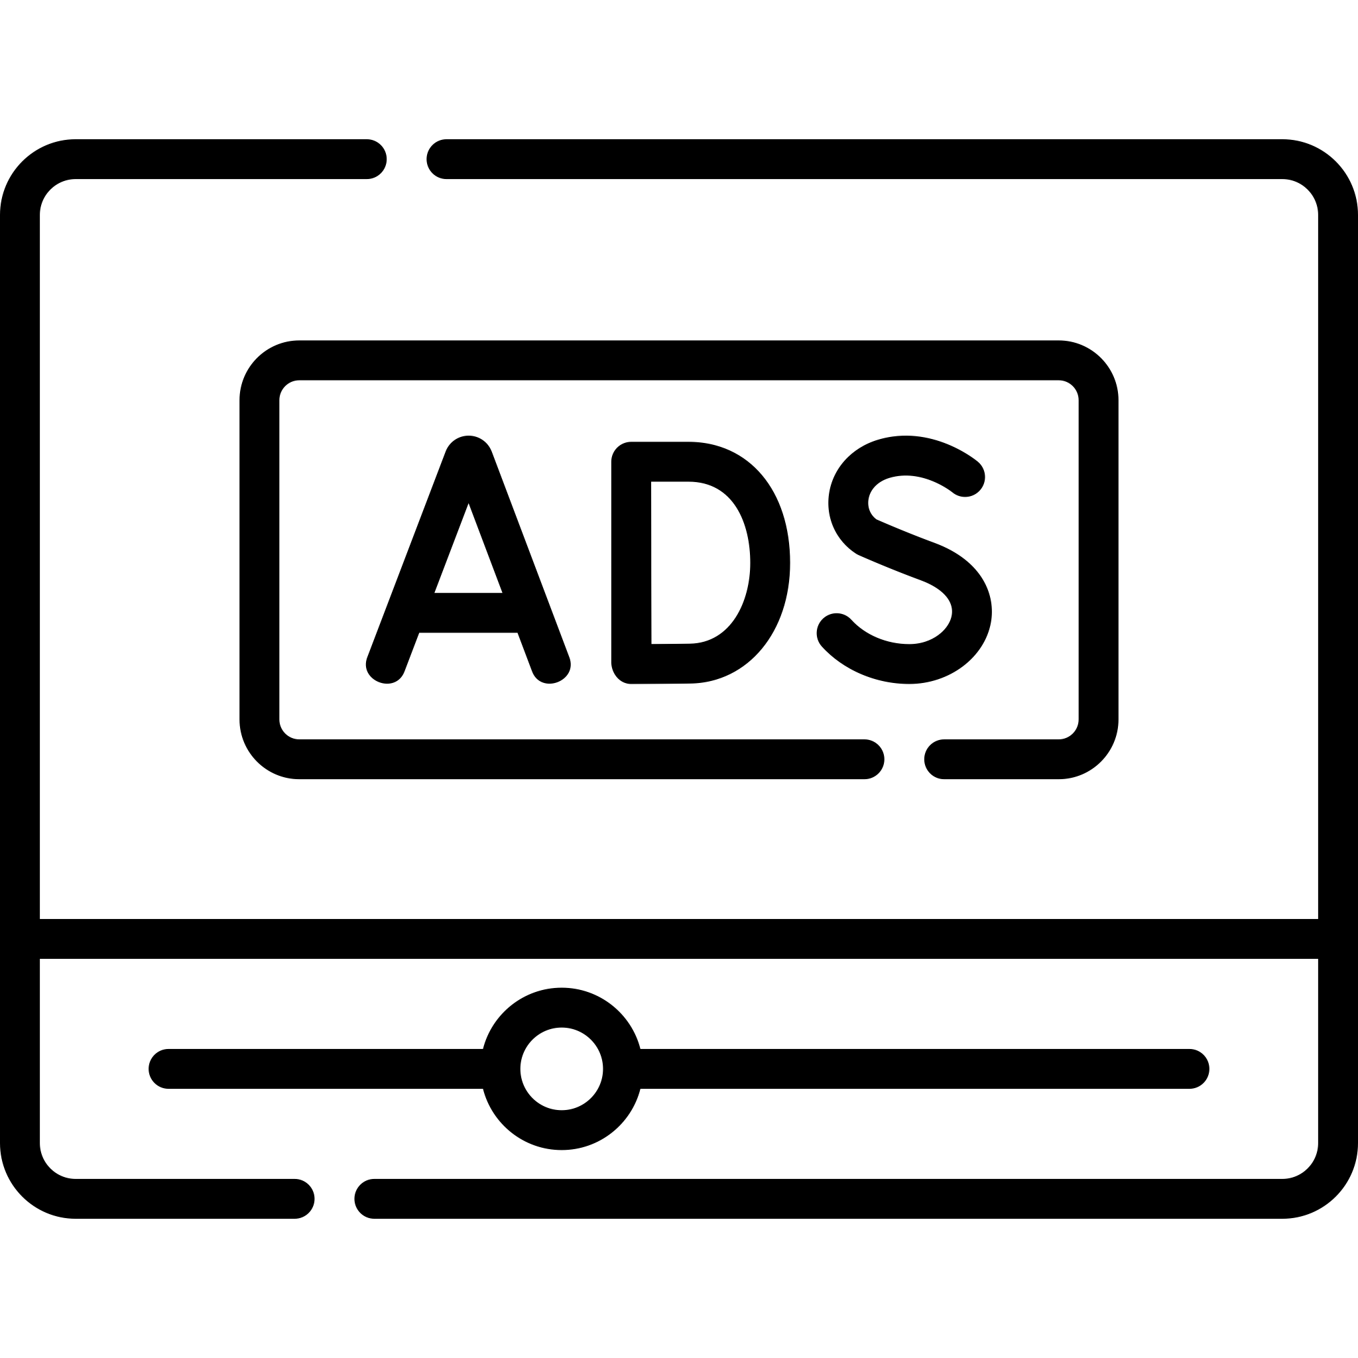  Video  Video commercials played before, during or after content shown to people on computers and mobile devices. | Use Case Example:  A local carpet cleaning professional wants to attract new business.  First, produce a video ad that shows before and after examples of the cleaning services. Then, use the video in a digital campaign that targets people in the local city who have pets or are interested in home improvement and have a household income above $50,000.

Geofencing and  Video geofencing  Display or video ads shown to people within a defined virtual fence and on devices with location services enabled. | Use Case Example:  A gym owner has just opened a new location.  First, create a video ad that gives a mini tour of the facility and offers a special promotion within the ad. Then, use the video in a geofencing campaign to reach people who visit competitor gyms.

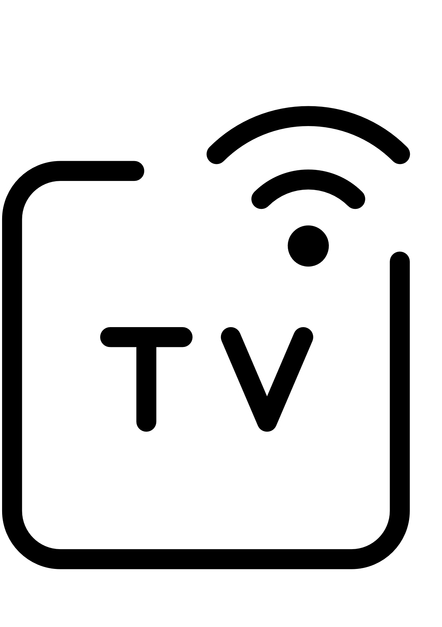  Connected TV (CTV)/Over-the-top (OTT)  Video commercials played before, during or after long form content on televisions or internet-streaming devices. | Use Case Example:  A family-friendly amusement park wants to bring in new patrons.  First, create a video ad to promote the park and all the fun amenities. Then, run a CTV/OTT digital campaign that targets homes within your region who have children.

Need help with creative?
We have you covered; we offer full display creative development services.

Sample Images
To download sample icons and images, please visit this link: https://bit.ly/30pjqoA

