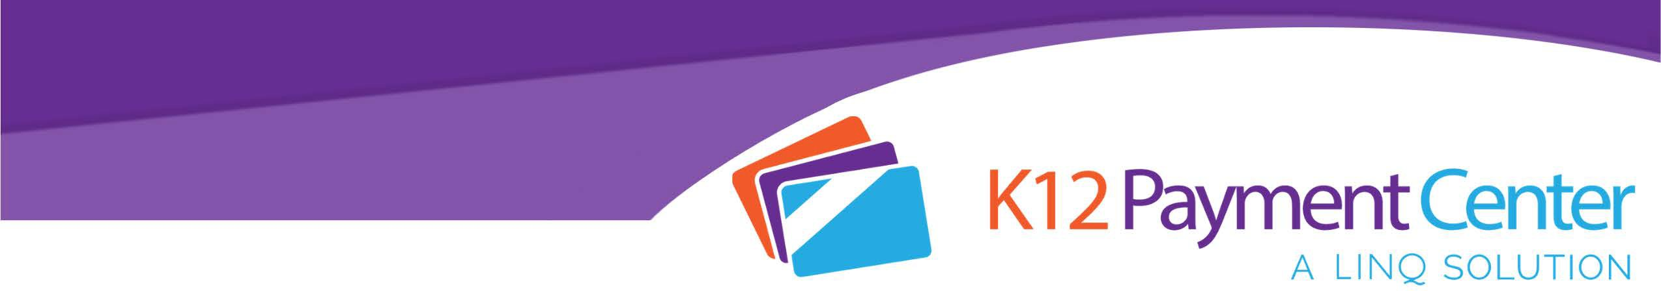

CONTACT:
Complete with your district information and fax or hand deliver to education and/or health reporters at local newspapers as well as radio & TV stations.
(District contact name) (District name)
(Phone #) (fax #)
(email address) (web address)

For Immediate Release:
Online Payment Website Allows Parents to Monitor Child Nutrition

(City, State) Month Day, Year - A new technology available to the school district of (district name) allows parents to easily make school meal payments online while tracking what their children are purchasing in the school cafeteria.

K12PaymentCenter offers parents many new and helpful features through their mobile app and web site at www.k12paymentcenter.com . These resources include enhanced monitoring options for managing low account balances. The technology gives parents the ability to set low balance
notifications for any desired amount and even transfer funds from one child to another in the same family. Another prominent feature is K12PaymentCenter’s secure access available 24/7 for parents to see their child’s entire purchasing history. This allows parents to gain some insight on the kind of food choices their child is making in the

cafeteria. “Good nutrition is essential to learning. If parents stay involved with nutrition the way they do with grades, it benefits the child. K12PaymentCenter makes it easier for parents to do this,” says (Child Nutrition Director name), child nutrition director for (District Name).

The Child Nutrition Services, a non-profit operation employing (#) people, operates (#) cafeterias in the (District name) serving over (#) meals per day – approximately (#) breakfasts and (#) lunches. We operate the National School Lunch Program and the National School Breakfast Program in all our schools. In conjunction with providing healthy, nutritious meals at a reasonable cost, we provide nutrition education for students as we seek to introduce our students to healthier meal time choices for a better way of life.

The K12PaymentCenter website was developed by EMS LINQ, Inc. (LINQ), a K-12 software company headquartered in Wilmington, North Carolina. LINQ is the first company to deliver a full suite of integrated solutions, including analytics, to help K-12 school districts better manage their operations. For more information, parents can visit K12PaymentCenter.com online or download the mobile app in their app store for facts on the program, tutorials and more.
###

